Name

Mathematics Advanced Year 12
The Normal Distribution

Book 1 | The normal distribution | Version: 260508  Feedback:  https://MrDingMaths.com
Contents
Syllabus Content 2
Learning Intention 3

Syllabus Content
MAV-12-07 solves problems involving discrete probability distributions, continuous random variables and the normal distribution
The normal distribution
- Identify the normal distribution as a continuous probability distribution that is used to model many naturally occurring phenomena
- Identify the graph of the probability density function of a normal distribution, the normal curve, as an ‘ideal’ bell-shaped curve, symmetrical about its mean which is equal to its mode and median, and as having most values concentrated about the mean
- Identify contexts that can be approximately modelled by a normal random variable
- Use the notation $X∼N\left(μ,σ^{2}\right)$ to represent a normally distributed random variable that has mean $μ$ and standard deviation $σ$
- Represent probabilities associated with the normal distribution by areas of shaded regions under the normal curve, which may extend to $±∞$
- Apply the empirical rule to make judgements and solve problems involving probabilities of normally distributed data: that for normal distributions, approximately 68% of data lie within one standard deviation of the mean, approximately 95% within two standard deviations of the mean and approximately 99.7% within three standard deviations of the mean
- Use graphing applications to explore the normal distribution, graph the probability density function $f\left(x\right)=\frac{1}{σ\sqrt{2π}}e^{-\frac{({x-μ)}^{2}}{2σ^{2}}}$, verify the empirical rule and graph the cumulative distribution function
- Recognise features of the normal curve, and identify the global maximum and points of inflection
- Distinguish between a standard normal distribution with mean 0 and standard deviation 1, and the non-standard normal distribution with mean $μ$ and standard deviation $σ$
- Define the $z$-score, or standardised score, by the formula $z=\frac{x-μ}{σ}$, where $μ$ is the mean and $σ$ is the standard deviation, and $x$ is an observed value of a random variable
- Interpret the $z$-score as the number of standard deviations a score lies above or below the mean
- Use $z$-scores to compare scores from different sets of data and justify conclusions
- Use $z$-scores to identify probabilities of events less or more extreme than a given outcome and solve problems using tables for the standard normal distribution
- Solve problems involving finding the mean or standard deviation of a normal random variable given the probability of an event less or more extreme than a given outcome
- Use $z$-scores to make judgements related to probabilities of certain events or given sets of data assuming an underlying normal distribution

Properties of the Normal Distribution

- The Normal Distribution
- The normal distribution is a special continuous probability distribution.
- A normal distribution is bell-shaped and symmetric about its mean.
- The mean, median, and mode are all equal.
- Values are concentrated near the mean, with fewer values further away.
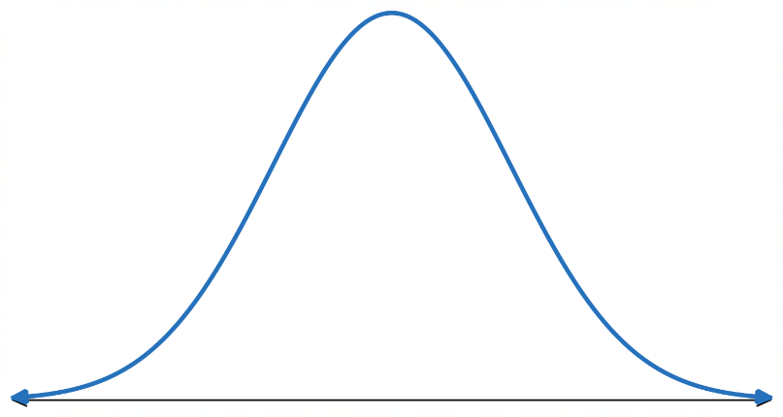

Mean
Median
Mode

- Identify a normal distribution
Identify which of the following histograms roughly follow a normal distribution.
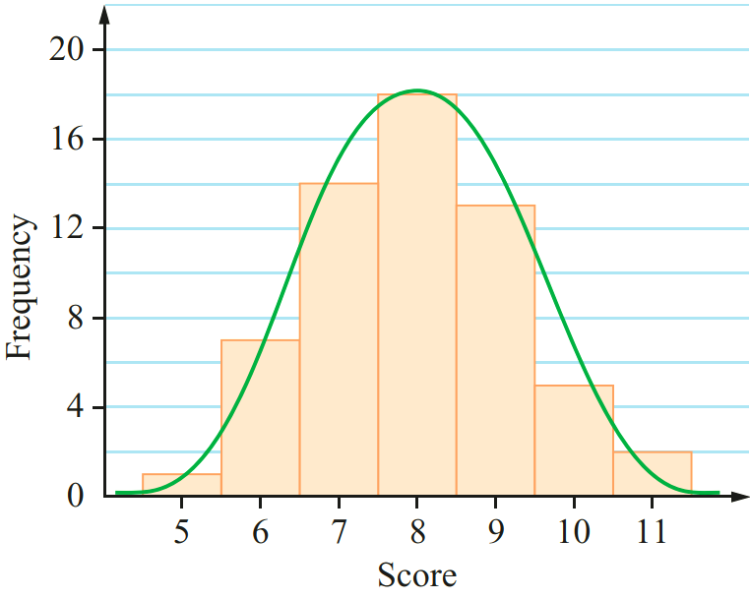  Yes. Symmetrical and bell-shaped. | 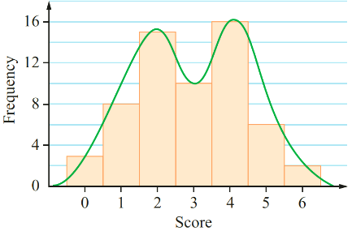 | 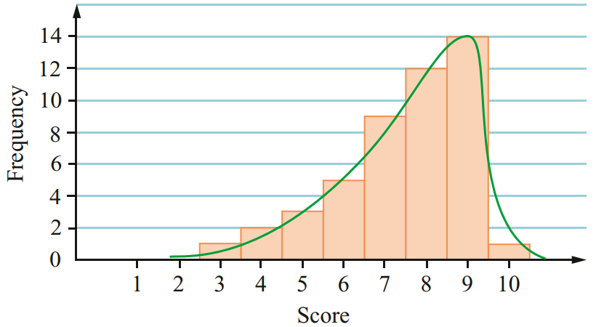
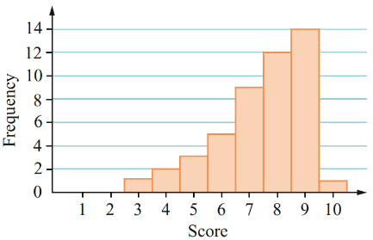 | 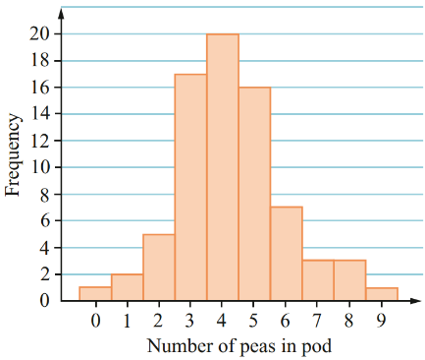 | 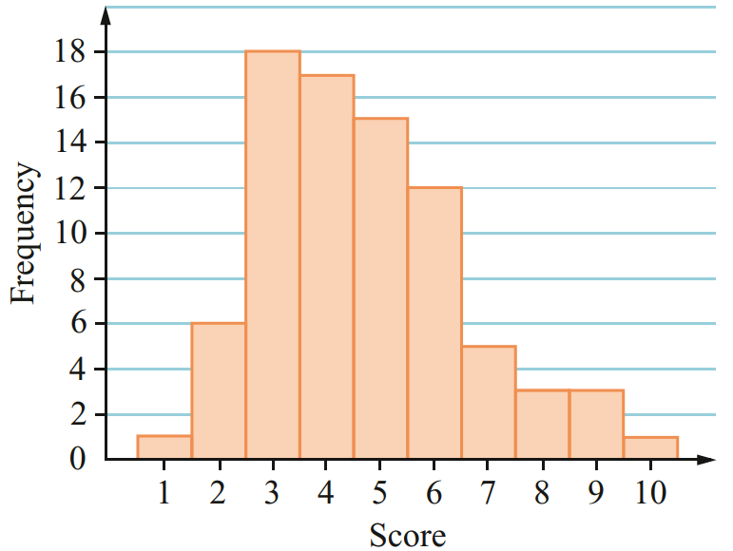

- Investigation Central limit theorem
Imagine you toss a coin 10 times. How many heads would you expect to get?

Why would you be unlikely to always get this number of heads?

Let’s see what happens when you do lots of trials.

- https://mrdingmaths.github.io/LawofLargeNumbers/
10 experiments of 10 coin tosses  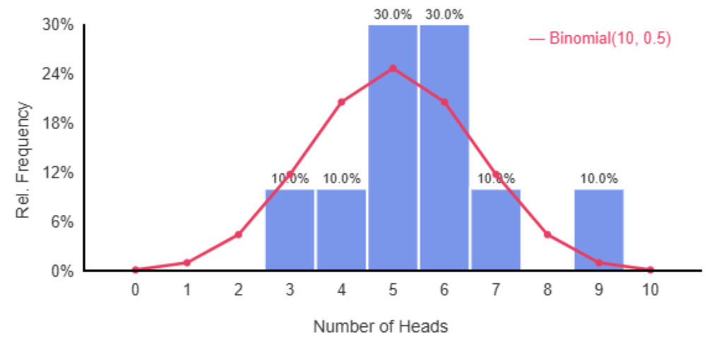 | 100 experiments of 10 coin tosses  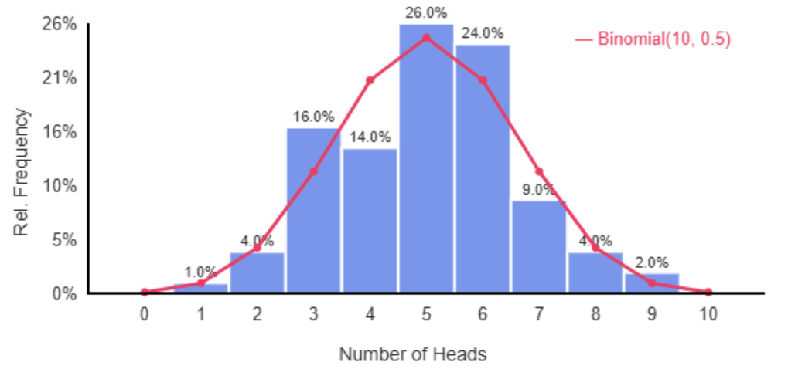
1000 experiments of 10 coin tosses  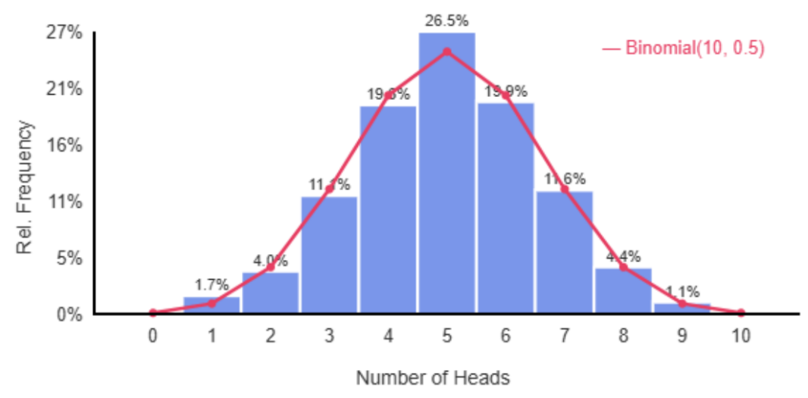 | 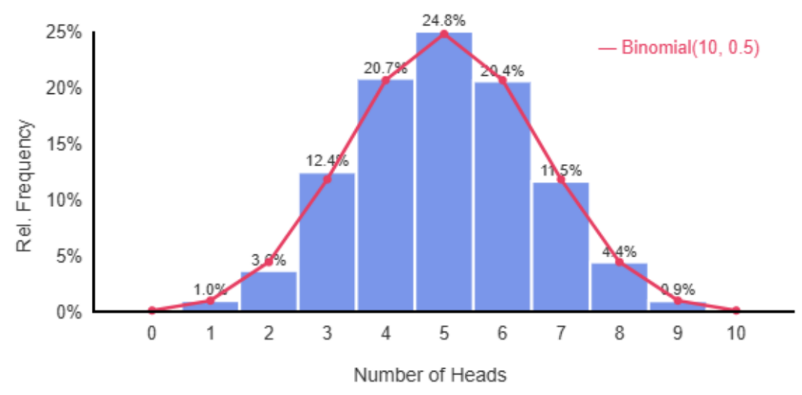  10000 experiments of 10 coin tosses

- Central Limit Theorem
The normal distribution is a bell-shaped probability distribution.
Many naturally occurring characteristics follow this shape when the data set is large enough.
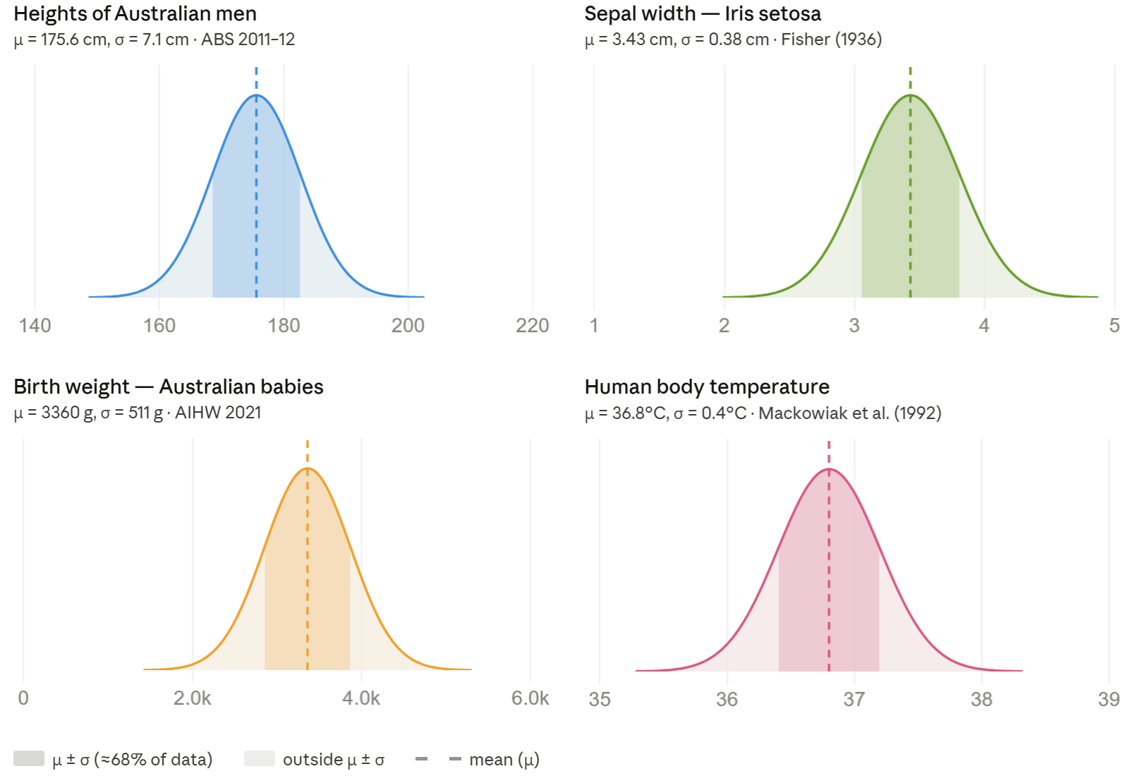

As the number of trials increases, a frequency distribution approaches a normal curve.
This is the Central Limit Theorem.

The Central Limit Theorem lets us assume that large data sets will have a predictable bell shape, making it possible to calculate probabilities for many real-world phenomena.

Foundation

- Which normal curve has the higher mean?  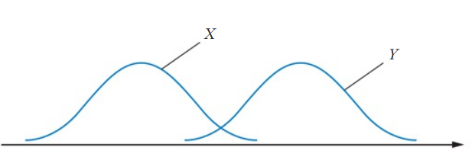  Y | 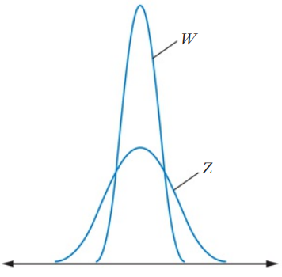  - Which normal curve has the higher standard deviation?  Z

- The normal curves below are drawn with the same scale on each horizontal axis and the same scale on each vertical axis. Which distribution has the:
  - Largest standard deviation? ……………
A
  - Smallest standard deviation? ……………
C
  - Largest mean? ……………
B
  - Smallest mean? ……………
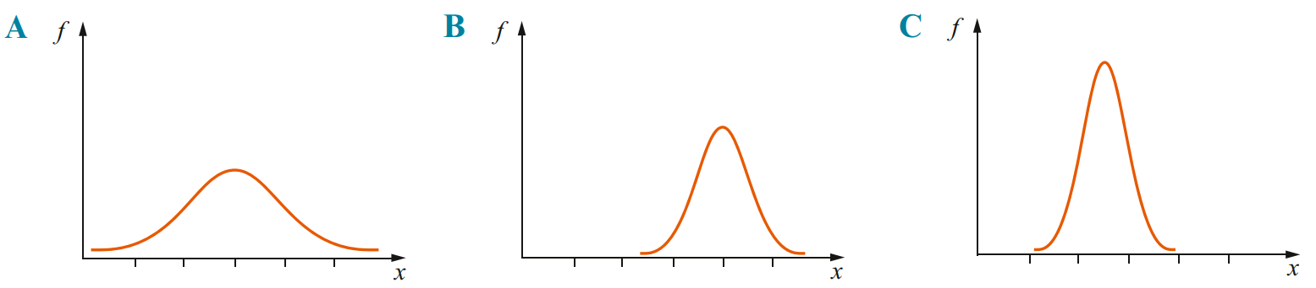
C

- Draw two normal curves with:
- the same mean but different standard deviations | - different means but the same standard deviation.

- The number of tomatoes on each plant of a large sample of a particular species of tomato is shown in the table.
Number of tomatoes on a plant | Number of plants
6 | 20
7 | 32
8 | 76
9 | 142
10 | 160
11 | 146
12 | 70
13 | 38
14 | 16

  - Draw a frequency polygon of the data.
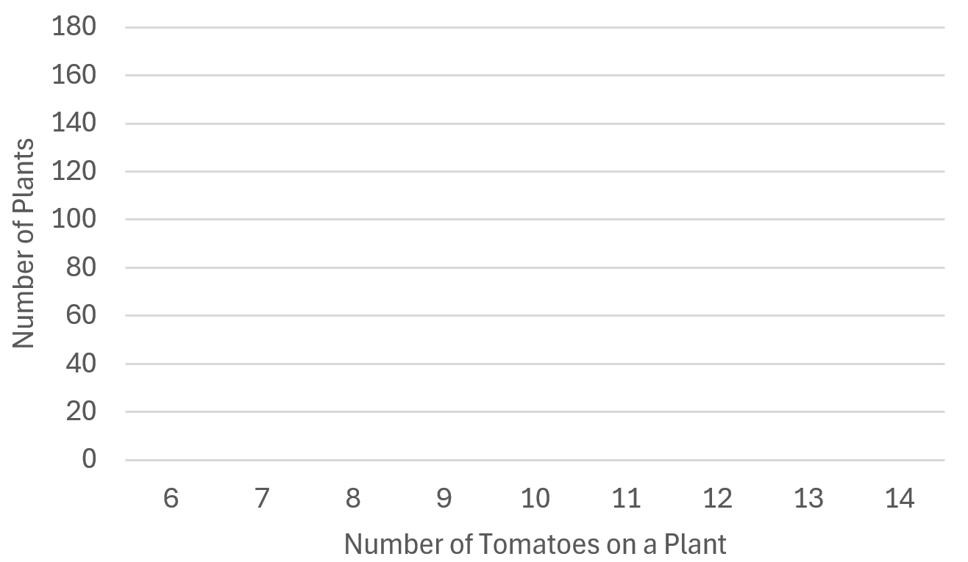

  - Calculate the mean, mode, median of the data.
Reminder: you will need to make the $xf$ and $cf$ columns on the table.

Mean: 10, Mode: 10, Median: 10
  - Justify whether this is approximately a normal distribution.

Yes, the mean median mode are all 10, and the data has a bell-shaped distribution.
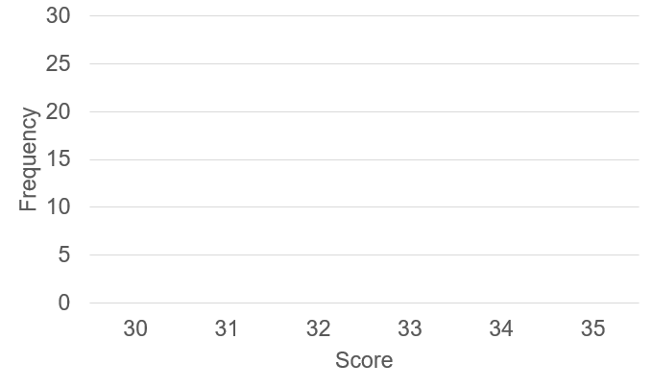
- Tommy says “The mean, median, mode of this dataset is 31, therefore it must be normally distributed.” By drawing the frequency polygon, explain why Tommy is wrong.
Score | Frequency
30 | 10
31 | 28
32 | 6
33 | 4
34 | 2
35 | 1

The distribution is not symmetrical, not “bell-shaped”

The z-score

- Review
- Work with mean $μ$and standard deviation $σ$
- A dataset has mean 10 and standard deviation 2.
- How many standard deviations above the mean is a score of 14? | - How many standard deviations below the mean is a score of 6?
- How many standard deviations above the mean is a score of 13? | - How many standard deviations below the mean is a score of 9?

- A dataset has mean 50 and standard deviation 5.
- A score is 2 standard deviations above the mean. What is the score? | - A score is 1 standard deviation below the mean. What is the score?
- A score is 3 standard deviations below the mean. What is the score? | - A score is 1.5 standard deviations above the mean. What is the score?

- Substitute into formulas
- $z =$ $\frac{x - μ}{σ}$  find $z$ when $x = 85, μ = 70, σ = 5$. | - $z =$ $\frac{x - μ}{σ}$  find $z$ when $x = 40, μ = 55, σ = 5$.

- The z-score
The z-score is the number of standard deviations that a value lies above or below the mean.
The z-score is positive if the data value is above the mean, and negative if the data value is below the mean. If the data value equals the mean, the z-score is zero.

- Identify sign of z-score
Value: 80  Mean: 70  $z$ is positive | Value: 60  Mean: 70  $z$ is negative | Value: 70  Mean: 70  $z$ is zero
Identify whether the z-score would be positive, negative, or zero.
- value = 45,  mean = 50  $z$-score:  Positive | Negative | Zero | - value = 85,  mean = 70  $z$-score:  Positive | Negative | Zero | - mean = 33,  value = 40  $z$-score:  Positive | Negative | Zero
- value = 87,  mean = 87  $z$-score:  Positive | Negative | Zero | - value = 112,  mean = 98  $z$-score  Positive | Negative | Zero | - mean = 180,  value = 100  $z$-score:  Positive | Negative | Zero

- Interpret z-score
$$z=2$$  2 standard deviations above the mean. | $$z=1.5$$  1.5 standard deviations above the mean. | $$z=-1$$  1 standard deviation below the mean.
Interpret these z-scores in context:
- $z=-2$  2 SD …………… mean | - $z=3$ | - $z=-1.2$
- $z=1.5$ | - $z=-2.3$ | - $z=4$

- Calculating the z-score
The z-score is how many standard deviations a score is from the mean.
raw score mean

$$z=\frac{x-μ}{σ}$$

standard deviation

- Example Calculate z-score
$μ$  In an English essay, the mean was 60 and the standard deviation was 10.  $σ$ $x$  Calculate the z-score for a mark of 55.  $$z=\frac{55-60}{10} \\ =-0.5$$ | $x$  A person is 178 cm tall. Heights are normally distributed with mean 168 cm and SD 7 cm.  $μ$ $σ$  Calculate the person’s z-score to 3 d.p.  $$z=\frac{178-168}{7} \\ =1.429$$

- Guided Practice
- IQ scores are normally distributed with mean 100 and standard deviation 15.  Find the z-score for an IQ of 127.  1.8 | - IQ scores have mean 100 and SD 15.  Find the z-score for an IQ of 85.  $$-1$$
- The birth masses of newborns are normally distributed with mean 3.4 kg and SD 0.5 kg.  Find the z-score for a newborn with mass 2.9 kg  $$-1$$ | - Millie scored 85 in a maths exam.  Find her z-score if the scores for the maths exam are normally distributed with mean 79 and standard deviation 4.2.  1.43

- Calculating the Raw Score from the z-score
mean z-score

$$x=μ+zσ$$

standard deviation

- Example Convert z-scores to raw scores
In a normal distribution the mean was 30 and the standard deviation was 3.5.
Blake achieved a z-score score of 2. Calculate Blake’s actual score.
$$x=μ+zσ \\ =30+2\left(3.5\right) \\ =37$$

- Guided Practice
- The marks on a test are normally distributed with a mean of 65 and a standard deviation of 8.  What mark corresponds to z-score of 1?  73 | - The marks on a test are normally distributed with a mean of 65 and a standard deviation of 8.  What mark is a z-score of $-2$?  49
- A class test has a mean mark of 34 and a standard deviation of 4. Mary’s standardised test mark was  $z = -1.5$.  What was Mary’s actual mark?  28 | - Jordan achieved a z-score of 2.5 for a reading test.  The mean for this reading test was 71.5 and the standard deviation was 6.4.  What mark did Jordan get?  87.5

- Key Ideas
- The z-score is how many ……………… ………………… a score is from the mean.
- A z-score is ……………… when it is below the mean, and ……………… when it is above.

Foundation
- What is the z-score that corresponds to a score that is:
  - Two standard deviations above the mean?
2
  - Two standard deviations below the mean?
$$-2$$
  - Three standard deviations above the mean?
3
  - 0.23 standard deviations below the mean?
$$-0.23$$

- Calculate the z-score, correct to one decimal place, for each of the following:
- $x=60,μ=75,σ=9$  $$-1.7$$ | - $x=22,μ=27,σ=2$  $$-2.5$$ | - $x=10,μ=5, σ=4$  $$1.3$$

- The mean height for a group of students is 180 cm with a standard deviation of 6 cm.
What is Julie’s standardised score (z-score) if her height is 171cm?

$$-1.5$$
- In an examination the mean was 65 and the standard deviation 10.
Write the raw examination mark corresponding to these standardised scores.
- 1  75 | - $-1$  55 | - 2  85
- 3  95 | - $-3$  35 | - 1.5  80
- 0.8  73 | - $-2.3$  42 | - $2.7$  92

- The monthly rainfall in Rockwaters has a mean of 55 mm and a standard deviation of 1.8 mm. What is the monthly rainfall if the standardised score was 3.2?

$60.8$ mm
- A normally distributed data set has mean 23 and standard deviation 2.
Which raw score has a $z$-score of 2.5?

$$x=μ+zσ=23+2.5\left(2\right)$$
$$=28$$
- In a History examination the mean was 56 and the standard deviation 8.
Complete the table, which shows the marks scored by some students.
Student | Mark | Standardised score |  | Student | Mark | Standardised score
Julie | 65 | 1.125 |  | Sam | 40 | $$-2$$
Imran | 48 | $$-1$$ |  | Megumi | 56 | 0
Sevvy | 72 | $$2$$ |  | Sasha | 38 | $$-2.25$$

- Holly gained a standardised score (z-score) of −3 for a fitness test.
  - Describe Holly’s results in terms of the mean and standard deviation of the test.

Holly's result was 3 standard deviations below the mean of the fitness test.
  - The fitness test has a mean of 75 and a standard deviation of 7.
What is the actual mark scored by Holly?

54
- A normally distributed data set has standard deviation 4.5. A score of 39 has a $z$-score of 2.7. Find the mean.

$$z=\frac{x-μ}{σ}$$
$$2.7=\frac{39-μ}{4.5}$$
$$μ=39-12.15=26.85$$
- The standard deviation of a normal distribution is 3.3 and the $z$-score of 45 is $-1$.
Find the mean.

$$-1=\frac{45-μ}{3.3}$$
$$μ=45+3.3=48.3$$

Development
- Find the standard deviation of a normally distributed data set with mean 89, if a raw score of 59 has $z$-score $-0.6$.

$$-0.6=\frac{59-89}{σ}$$
$$σ=\frac{-30}{-0.6}=50$$
- An assessment task is marked out of 20. The results of the test are shown below.

10 11 19 17 14 15 17 11 12 14 8 16 18 20 14 13

  - Calculate the mean and population standard deviation for these scores.
Answer correct to one decimal place.

Mean: 14.3, $σ=3.3$
  - What is the z-score of the student who scored the lowest on the test? Answer to 1 d.p.

$$-1.9$$
  - Lucy was absent for this task, but her mark is usually 1.5 standard deviations above the mean. What mark should her teacher give her as an estimate?

19.25
- An assessment task is marked out of 100. The results of the test are shown below.

75 80 65 66 79 83 61 77 87 88 67 74 79 75 80 81

  - Calculate the mean and population standard deviation for these scores.
Answer correct to one decimal place.

$$μ=76.1, σ=7.6$$
  - What is his z-score of the student who scored the highest on the test? Answer to 1 dp.

1.6
  - Mason was absent for this task, but his mark is usually 1.9 standard deviations below the mean. What mark should his teacher give him as an estimate?

61.66

Comparing Performance using the z-score

- Review
- Interpret z-score
- A student has $z = 2$ in their maths test and $z=3$ in their science test.  In which test did they perform better relative to the class? | - A student has $z=-2$ in their maths test and $z=-3$ in their science test.  In which test did they perform better relative to the class?
- For time to swim 50 metres, a student has $z=2$ for freestyle and $z=3$ for butterfly. In which were they faster? | - For time to swim 50 metres, a student has $z=-1$ for freestyle and $z=0$ for butterfly. In which were they faster?

- Investigation Applications of the z-score
Consider two tests with scores that are normally distributed with the same mean, but different standard deviations:
Mean: 70, SD: 5 Mean: 70, SD: 10
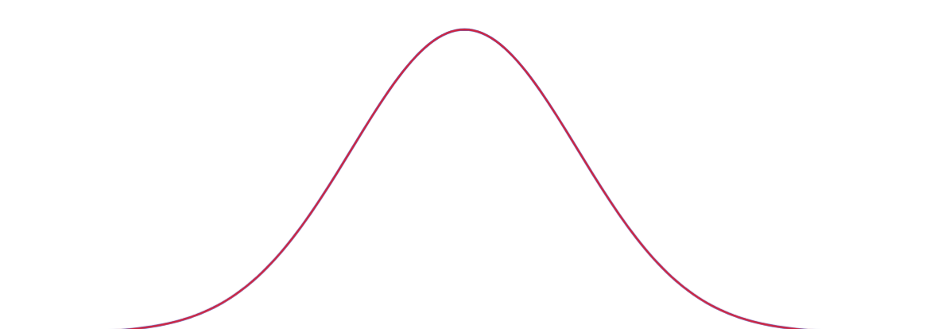

If someone scored 85. In which test have they performed better, relative to the cohort?
What would your answer be, without any calculation?

Confirm this by calculating the z-score for each test.

If you score 85 in the first test, what would the equivalent score of the same z-score be in the second test?

- Comparing Performance using z-scores
A higher z-score is usually better, such as in test scores.
A lower z-score can sometimes be better, such as time to complete a task.

- Example Compare performance using z-scores
Cate’s test scores are shown below:  English: score: 55, mean: 50, SD: 6.  Maths: score: 64, mean: 59, SD: 9.  In which test did she perform better?  $$z_{E}=\frac{55-50}{6}=0.83$$  $$z_{M}=\frac{64-59}{9}=0.56$$  She performed better in English, as a higher test score is better. | In the swimming carnival, Olivia participated in two events:  Freestyle: time: 50 s, mean: 50, SD: 5,  Backstroke: time: 80s, mean: 90, SD: 4.  In which event did she perform better?  $$z_{F}=\frac{50-50}{5}=0$$  $$Z_{B}=\frac{80-90}{4}=-2.5$$  She performed better in backstroke, as a faster time is better.

- Guided Practice
- In which subject was Amelie’s test performance better?
Justify your answer using the z-scores.

Maths: score 78, mean 70, SD 4.
English: score 83, mean 79, SD 4.

Maths. Her score was 2 standard deviations above the mean, compared to 1 in English.
- In which subject was Willa’s test performance better?
Justify your answer using the z-scores.

Maths: score 55, mean 60, SD 5
English: score 68, mean 70, SD 4

English. Her score was only 0.5 standard deviations below the mean, compared to 1 in Maths.
- In which event was Aspen’s performance better?
Justify your answer using the z-scores.

100 m: time: 10, mean 12, SD 3
200 m: time: 22, mean 25, SD 5

100 m. Her z-score was more negative, meaning she was further below the mean time.
- Finding the Equivalent Score
For a score in dataset A, to find the equivalent score in dataset B:
1. Calculate z-score of the raw score in dataset A. $z_{A}=$ $\frac{x_{A}-μ_{A}}{σ_{A}}$
2. Calculate the raw score in dataset B using dataset A’s z-score. $x_{B}=μ_{B}+z_{A}σ_{B}$

- Example Find the equivalent score using the z-score
Charlotte scored 64 in a mathematics test in which the mean was 59 and SD was 9.
The English test has a mean of 50 and SD of 6.
What mark would she have to score in English for her performance to be equivalent?
1. Calculate z-score for maths  $$z_{M}=\frac{x_{M}-μ_{M}}{σ_{M}} \\ z_{M}=\frac{64-59}{9} \\ =0.56$$ | 2. Calculate equivalent score in English using maths z-score  $$x_{E}=μ_{E}+z_{M}σ_{E} \\ =50+0.56\left(6\right) \\ =53.36$$

- Guided Practice
Liam scored 72 in a science test in which the mean was 60 and the SD was 8.
The history test has a mean of 55 and SD of 4.
What mark would he need to score in history for his performance to be equivalent?

61
Maya scored 45 in a geography test in which the mean was 50 and the SD was 5.
The art test has a mean of 60 and SD of 8.
What mark in art would represent an equivalent performance?

52

Foundation
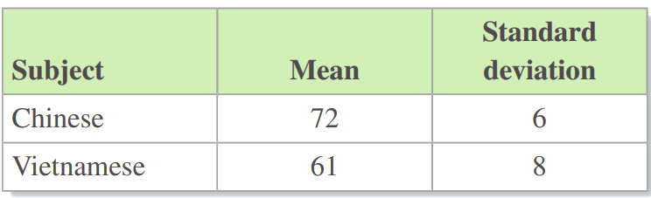
- The table shows the mean and standard deviation of the results in a Chinese and a Vietnamese exam.

Hoang scored 81 in Chinese and 77 in Vietnamese.
  - What is Hoang’s z-score for his result in Chinese?

1.5
  - What is Hoang’s z-score for his result in Vietnamese?

2
  - In which of the two exams was his result better? Justify your answer.

Vietnamese, he has a higher z-score in Vietnamese so his performance relative to the group was stronger.
- Tom scored 78% on a Science test and 72% on a Mathematics test.
  - In which test does Tom appear to have performed better?

Looking only at the raw scores, Tom appears to have performed better in the Science test (78%) than in the Mathematics test (72%).
  - The mean score for the Science test was 66% and the mean score for the Mathematics test was 62%. Using this information and Tom’s test scores, in which test does he appear to have performed better?

Tom still appears to have performed better in Science as he scored 12% above the mean, compared to 10% above the mean in Mathematics.
  - The standard deviation of the scores for the Science test was 6% and the standard deviation of the scores for the Mathematics test was 4%. Using all the information you now have, in which test has Tom performed better? Explain your answer.

Tom performed better in Mathematics with a z-score of 2.5 compared to 2.0 in Science.
The standard deviation in Mathematics (4%) was smaller than in Science (6%), indicating that scores were more tightly clustered around the mean.
This makes Tom's achievement of scoring 10% above the mean in Mathematics more significant than scoring 12% above the mean in Science.
- Complete the following table, which shows Issy’s marks in her yearly examinations.
Subject | Mark | Mean | SD | Z-score
English | 51 | 55 | 5 | $$-0.8$$
Maths | 64 | 60 | 12 | 0.33
Biology | 62 | 58 | 8 | 0.5
Art | 76 | 56 | 9 | 2.22
Economics | 58 | 58 | 14 | 0
History | 51 | 60 | 11 | $$-0.82$$

  - In which subject was her relative performance the best?
Art
  - Did she perform better in English or History?
English. $-0.8$ is greater than $-0.82$
  - In which subject was her relative performance the worst?
History
- The marks for five students in the Physics examination are shown.
In the half-yearly the mean was 60 and the standard deviation was 16.
In the yearly examination the mean was 58 and the standard deviation is 12.
  - Fill in the tables, also calculate the change in the z-score.
Student | Mark | z score |  | Mark | z score |  | Change
Olivia | 71 | 0.69 |  | 69 | 0.92 |  | +0.23
Harriet | 41 | $$-1.19$$ |  | 40 | $$-1.5$$ |  | -0.31
Trinity | 84 | 1.5 |  | 80 | 1.83 |  | +0.33
Hannah | 51 | $$-0.56$$ |  | 59 | 0.08 |  | +0.64
Karla | 62 | 0.13 |  | 52 | $$-0.5$$ |  | -0.63

  - With reference to the z-score, which students improved the most?
Hannah, her z-score increased the most
  - Which students performed worse in the second examination?
Harriet and Karla
  - Which student’s performance decreased the most?
Karla, her z-score decreased the most
  - Which student’s performance was the most consistent?
Olivia, her z-score changed the least.

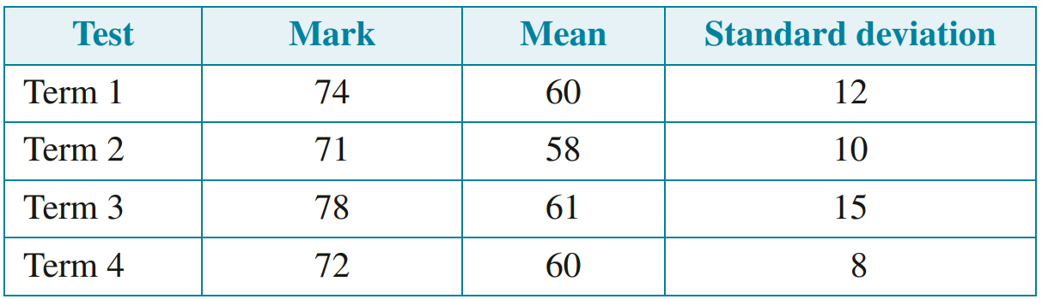
Development
- The table shows Melissa’s marks in four Mathematics tests.

1.17
1.3
1.13
1.5

  - Add a z-score column to the table and calculate the standardised scores.
  - In which term was her relative performance best?
Term 1
  - In which term was her relative performance worst?
Term 3
  - Did her performance improve or worsen from:
    - Term 1 to term 2?
improved
    - Term 2 to term 3?
worsened
    - Term 3 to term 4?
improved
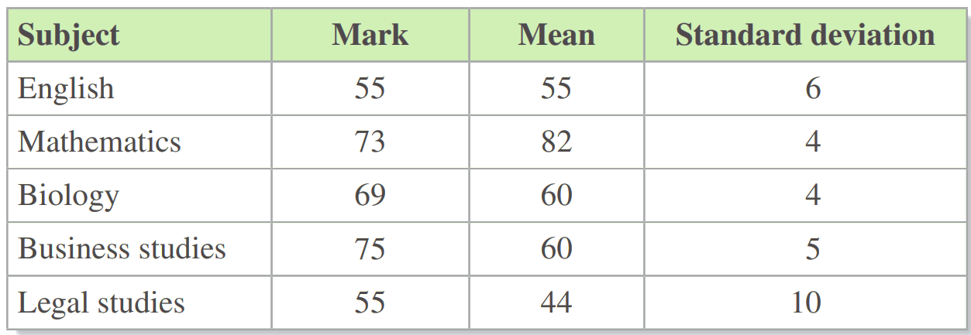
- The table below contains the scores a student obtained in the Trial HSC.
Also shown is the mean and standard deviation for each subject

0
-2.25
2.25
3
1.1
  - Add a new column to the table and calculate their z-score for each subject.
  - Use the z-score to rate their performance in each subject from the best performing subject to the worst performing subject.
Business studies, Biology, Legal Studies, English, Mathematics
  - The Mathematics result was entered incorrectly. The mean was 62 not 82.
How did above error affect the z-score Mathematics? Give reasons for your answer.

The change to the mean changes her z-score from -2.25 to 2.75. This means the student performed exceptionally well in Maths.
- Michael compared his recent marks in two subjects:
Construction: mark 77, mean 64.6, standard deviation 10.1
Legal studies: mark 74, mean $\overline{x}$, standard deviation 12.5
  - What is Michael’s z-score (correct to two decimal places) for his mark in Construction?

1.23
  - Michael achieved the same z-score in both Construction and Legal studies.
What is the mean for Legal studies? Answer correct to one decimal place.

58.6
  - What mark does Michael require in Construction to achieve a z-score of 2?

84.8
  - What mark does Michael require in Legal studies to achieve a z-score of 2?

83.6

The 68 – 95 – 99.7 (or Empirical) Rule

- Review
- Work with z-score
- A distribution has mean 450 and SD 35. Find the z-score for a value of 380. | - A distribution has mean 450 and SD 35. Find the z-score for a value of 520.
- A normal distribution has mean 72.  If z = 1 corresponds to the value 80, what value corresponds to z = −1? | - A normal distribution has mean 50.  If z = 2 corresponds to the value 75, what value corresponds to z = −2?

- Empirical Rule
In a normal distribution, specific percentages of data always fall within certain standard deviation ranges.
68% of data have z-scores  between −1 and 1 | 95% of data have z-scores  between −2 and 2
99.7% of data have z-scores  between −3 and 3 | 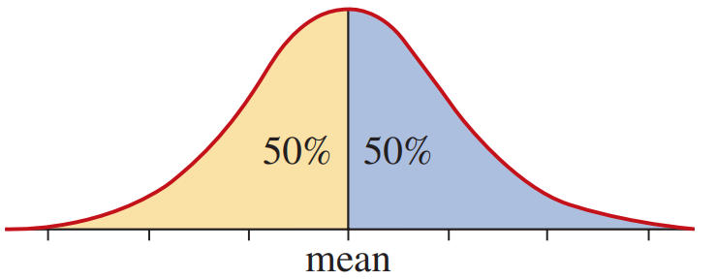  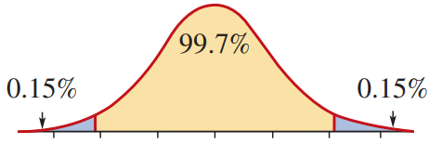  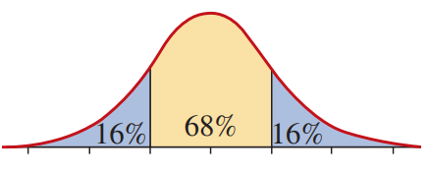  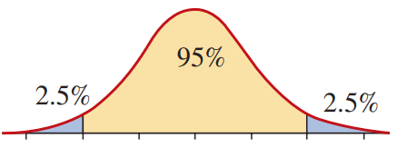  50% of data lie above the mean and  50% of data lie below the mean.

- Empirical Rule
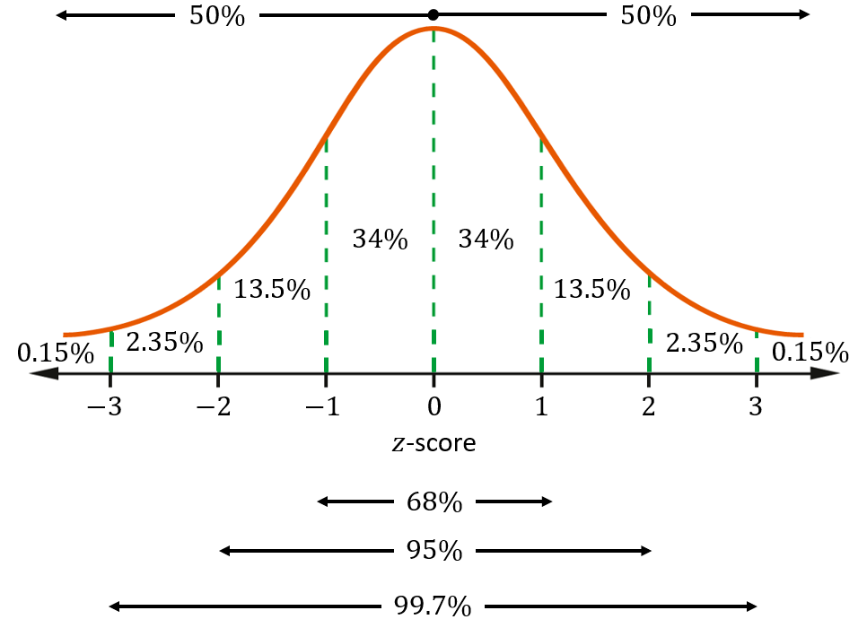

- Apply empirical rule
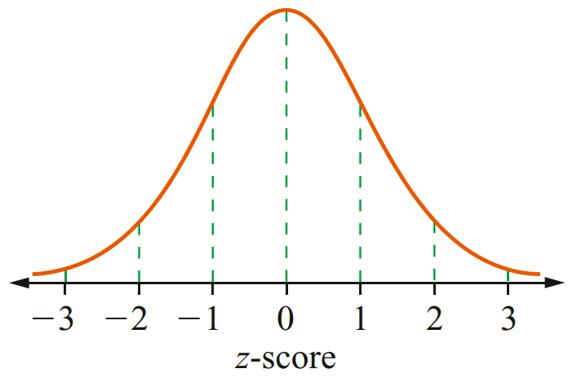
Shade in these normal curves to and give the percentage of scores in the given z-score range
$$z≤0$$ | $$z≥0$$ | $$0≤z≤1$$
$$-2≤z≤0$$ | $$1≤z≤2$$ | $$z≤1$$

Foundation
- Use the graphs to answer these questions.
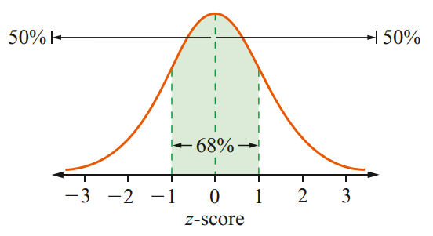
  - What percentage of scores have a z-score:
between −1 and 1?  68$ | between 0 and 1?  34%
between 0 and −1?  34% | greater than 0?  50%
less than 0?  50% | greater than 1?  16%
less than −1?  16% | greater than −1?  84%

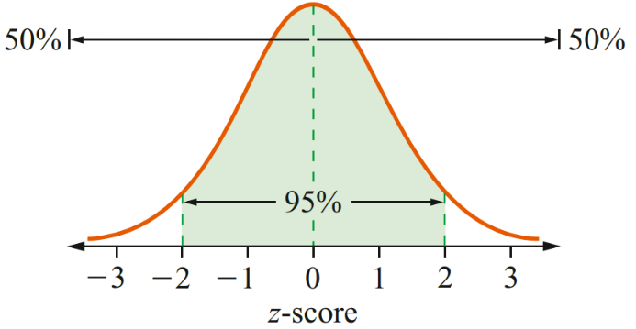
  - What percentage of scores have a z-score:
between −2 and 2?  95% | between 0 and 2?  47.5%
between 0 and −2?  47.5% | greater than 2?  2.5%
less than −2?  2.5% | greater than −2?  97.5%
less than 2?

97.5%

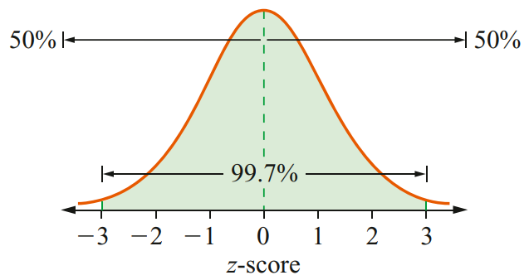
  - What percentage of scores have a z-score:
between −3 and 3?  99.7% | between 0 and 3?  49.85%
between 0 and −3?  49.85% | greater than 3?  0.15%
less than −3?  0.15% | greater than −3?  99.85%
less than 3?

99.85%

Development
- What proportion of scores is shaded in each diagram?
34% | 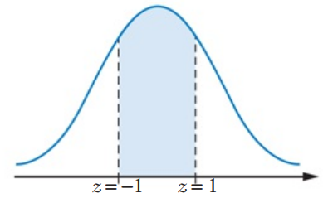  68% | 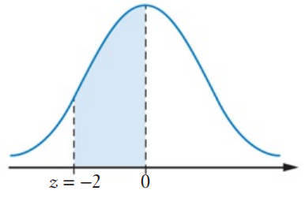  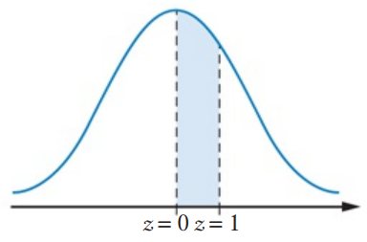  47.5%
99.7% | 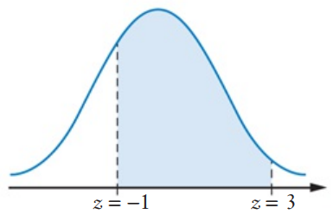  83.85% | 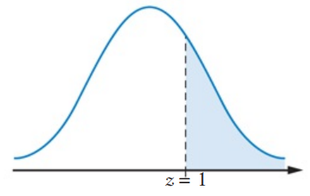  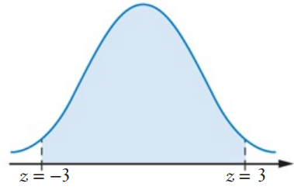  16%

- What percentage of scores have a z-score between:
- 1 and 2?  13.5% | - 1 and 3?  15.85% | - 2 and 3?  2.35%
- −1 and 2?  81.5% | - −1 and 3?  83.85% | - −2 and 1?  81.5%
- −2 and 3?  97.35% | - −3 and 1?  83.85% | - −3 and 2?  97.35%

- Using only the given information, fill in the missing percentages of the normal curve.
(you will need to do this in an exam as the normal curve is not given to you)

See diagram in notes section for answer

Applications of the Empirical Rule

- Interpret raw-scores on a normal distribution curve
Write the corresponding raw score under the z-score for these datasets
mean 25, SD 5  10 15 20 25 30 35 40 | mean 450, SD 35
mean 12, SD 2 | mean 10, SD 4
mean 100, SD 20 | mean $-$10, SD 5

- Applying the Empirical Rule
When answering normal distribution questions related to the empirical rule, always sketch the normal curve and put on the corresponding raw scores.

- Example Apply the empirical rule to solve problems
The distribution of delivery times for pizzas made by Pizza House is approximately normal, with a mean of 25 minutes and a standard deviation (SD) of 5 minutes.

10 15 20 25 30 35 40
- What percentage of pizzas have delivery times of between 20 and 30 minutes?
This is $-1≤z≤1$. So, 68%
- What percentage of pizzas have delivery times of greater than 30 minutes?
This is $z≥1$. So, 16%
- In a month, Pizza House delivers 2000 pizzas. How many of these pizzas are delivered in less than 10 minutes?
This is $z<-3$. $0.15\%×2000=3$

- Guided Practice
In a normal distribution, the mean recovery time after contracting a certain disease is 12 days with a standard deviation (SD) of 2 days.
- What percentage of patients would recover within 8 to 16 days?
- What percentage of patients would recover within 16 days?
- If 400 patients contracted the disease last year, how many recovered within 10 days?

95%, 97.5%, 64

Development
- The lifetimes of batteries used in a toy have a mean of 12 hours and a standard deviation of 3 hours. The battery lifetimes are normally distributed.
  - write the corresponding mark underneath each z-score then answer the questions.
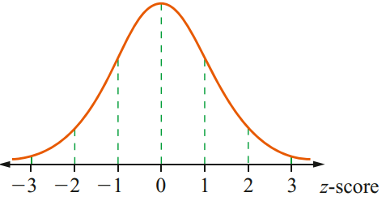

  - 50% of the batteries have lifetimes above ……………
12 hours
  - 68% of the batteries have lifetimes between ……………and ……………
9 hours and 15 hours
  - 95% of the batteries have lifetimes between ……………and ……………
6 hours and 18 hours
  - 99.7% of the batteries have lifetimes between ……………and ……………
3 hours and 21 hours
- The blood pressure readings for seniors are normally distributed with a mean systolic blood pressure of 134 and a standard deviation of 20. Given this information it can be concluded that:
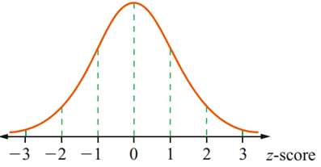
  - Sketch the normal curve and answer these questions.

  - 68% of the seniors have blood pressures between ……………and ……………
114 and 154
  - 95% of the seniors have blood pressures between ……………and ……………
94 and 174
  - 99.7% of the seniors have blood pressures between ……………and ……………
74 and 194
  - 16% of the seniors have blood pressures above ……………
154
  - 2.5% of the seniors have blood pressures below ……………
94
  - 0.15% of the seniors have blood pressures below ……………
74
  - 50% of the seniors have blood pressures above ……………
134
- The mean length of a garden stake is 180 cm. The standard deviation of the lengths is 3 cm. The length of the garden stakes is normally distributed.
What percentage of the garden stakes lie between:
  - 177 cm and 183 cm? ………………………
68%
  - 174 cm and 186 cm? ………………………
95%
  - 171 cm and 189 cm? ………………………
99.7%

- The weights of packets of potato chips are normally distributed.
The mean is 200 grams and the standard deviation is 8 grams.

  - What percentage of packets have a weight between 184 grams and 216 grams?
95%
  - What percentage of packets have a weight between 192 grams and 208 grams?
68%
  - What percentage of packets have a weight between 176 grams and 224 grams?
99.7%
  - What percentage of packets have a weight greater than 200 grams?
50%
- The distribution of heights of 19-year-old women is approximately normal, with a mean of 170cm and a standard deviation of 5cm.
  - What percentage of these women have heights:
    - between 155 and 185cm? ………………
99.7%
    - greater than 180cm? ………………
2.5%
    - between 160 and 180cm? ………………
95%
  - In a sample of 5000 of these women, how many have heights:
    - between 155 and 185cm? ………………
4985
    - greater than 180cm? ………………
125
    - between 160 and 180cm? ………………
4750
- A machine fills packets of lollies. The mean number of lollies in each packet is 40 with a standard deviation of 1.5 lollies. The number of lollies is normally distributed. Rory claims that he bought a packet that had 48 lollies in it. Discuss Rory’s claim.

This is a z-score of 5.33, which is extremely unlikely.
- Nathan sells a diet plan with a money-back guarantee if the customer does not lose 9 kg in the first three months. The weight loss after three months is normally distributed with a mean loss of 13.2 kg and a standard deviation of 1.4 kg.
  - What is the z-score corresponding to a weight loss of 9 kg?

$$-3$$
  - What percentage of customers will not reach the 9 kg in three months?

0.15% of data is below a z-score of $-3$
  - Nathan has sold 2000 diet plans. How many refunds are expected?

3 refunds

- A train is timetabled to arrive at Central station at 8:44 am each day of the week. After 3 months the mean arrival time was 8:44 am with a standard deviation of 3 minutes. The data is normally distributed.
  - What percentage of times will the train arrive between 8:38 am and 8:50 am?
95%
  - What percentage of times will the train arrive between 8:35 am and 8:47 am?
99.85%
  - What percentage of times will the train arrive before 8:38 am?
2.5%
  - What percentage of times will the train arrive after 8:47 am?
16%
  - What percentage of times will the train arrive on time or earlier?
50%
  - Sydney Trains does not classify a train as late unless it arrives 6 minutes later than the scheduled time. What percentage of times will the train arrive late?
2.5%
  - How often will this train run late, according to Sydney Trains, in 200 days?
5 days

Mastery
- A normal distribution has a standard deviation of 3. If 16% of the scores are at least 29,
find the mean.

16 represents a z-score of $-1$
So, the mean is 19
- A normal distribution has a mean of 95. If 2.5% of the scores are below 73,
find the standard deviation.
73 represents a z-score of $-2$
The difference between the mean, 95, and the score, 73, is 22
22 represents 2 standard deviations.
11 is the standard deviation.

- A set of data is normally distributed with mean 18 and standard deviation 2.
Find the percentage of data between:
- 16 and 20  68% | - 14 and 22  95% | - 12 and 24  99.7%
- 16 and 18  34% | - 18 and 24  49.85% | - 12 and 22  97.35%

- A normal distribution has mean 65 and standard deviation 4.
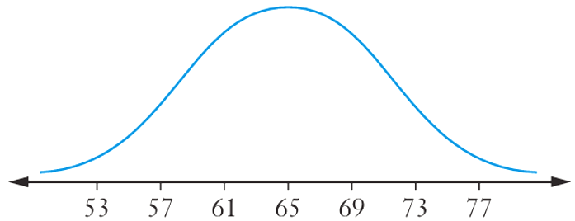
  - Sketch the graph.

  - Find the percentage of data between:
- 57 and 73  95% | - 61 and 65  34% | - 65 and 77  49.85%
- 57 and 69  81.5% | - 61 and 73  81.5%

- Fish lengths in a competition had mean 53.1 cm and standard deviation 8.7.
  - Between which lengths would fish almost certainly lie (within 3 standard deviations)?

$μ±3σ=53.1±26.1$
27 cm to 79.2 cm
  - Find the $z$-score for each length:
- 53.1 cm  0 | - 61.8 cm  1 | - 44.4 cm  $$-1$$ | - 70.5 cm  2
- 35.7 cm  $$-2$$ | - 79.2 cm  3 | - 27 cm  $$-3$$ | - 65 cm  1.4

- Overnight temperatures at Thredbo in June had mean 6.8°C and standard deviation 1.1.
  - Within what range do almost all temperatures lie (3 standard deviations)?

$μ±3σ=6.8±3.3$
3.5°C to 10.1°C
  - Find the $z$-score for:
- 6.8°C  0 | - 7.9°C  1 | - 9°C  2 | - 10.1°C  3
- 5.7°C  $$-1$$ | - 4.6°C  $$-2$$ | - 3.5°C  $$-3$$ | - 6°C  $$-0.7$$

- A normally distributed data set has mean 16 and standard deviation 1.9.
  - Find the scores between which:
- 95% of data lies  $$μ±2σ=16±3.8$$  12.2 to 19.8 | - 68% of data lies  $μ±σ$  14.1 to 17.9 | - 99.7% of data lies  $$μ±3σ$$  10.3 to 21.7

  - Calculate the $z$-score of:
    - 20
    - 13.5
$$i z=\frac{20-16}{1.9}≈2.1$$
$$ii z=\frac{13.5-16}{1.9}≈-1.3$$
  - Find the raw score with $z$-score:
    - $-3$
    - $1.1$
i $x=16+(-3)(1.9)=10.3$
ii $x=16+1.1(1.9)=18.09$

- Apple diameters are normally distributed with mean 7.5 cm and standard deviation 0.3 cm. Only apples within 2 standard deviations are allowed.
  - What percentage of apples are allowed?
95%
  - What is the largest diameter allowed?
$μ+2σ=8.1$ cm
  - What is the smallest diameter allowed?
$μ-2σ=6.9$ cm

- Bread mix bags have mean weight 4.95 kg and standard deviation 0.15 kg.
Bags are rejected if under 4.65 kg or over 5.25 kg.
  - What percentage are rejected?
$$z\left(4.65\right)=\frac{4.65-4.95}{0.15}=-2; z(5.25)=\frac{5.25-4.95}{0.15}=2$$
95% accepted, so 5% rejected
  - What percentage are rejected for being too light?
$$P(X<4.65)=P(Z<-2)=2.5\%$$
  - The manager changes the rule: only bags outside 3 standard deviations are rejected.
    - What percentage will be rejected?
0.3%
    - What weights will be rejected?
$x<μ-3σ=4.5$ kg
or $x>μ+3σ=5.4$ kg
- Steel rods have mean diameter 10.6 cm and standard deviation 0.5 cm.
  - If 0.3% of rods are rejected, find:
    - the percentage accepted
99.7% accepted
    - the largest diameter accepted
$μ+3σ=12.1$ cm
    - the smallest diameter accepted
$μ-3σ=9.1$ cm
  - In one batch, diameters are 10.9 cm, 9.6 cm, 8.3 cm, 11.4 cm, 12.6 cm.
Which are rejected?

Acceptable range: 9.1 to 12.1 cm. Rejected: 8.3 cm and 12.6 cm.

- A canned fruit manufacturer guarantees minimum weight 250 g.
The cans have mean 252.5 g and standard deviation 0.4 g. Is the guarantee realistic? Why?

Minimum expected weight at when $z=-3$:
$μ-3σ=252.5-1.2=251.3$ g $>250$ g. The guarantee is realistic.
- The width of a door type almost certainly lies in the range 814 mm to 826 mm (3 standard deviations from the mean).
  - Find the standard deviation.

Range 814 to 826 spans $2×3σ$.
$$6σ=826-814=12$$
$σ=2$ mm
  - Find the mean width.

$μ=\frac{814+826}{2}=820$ mm
  - Within what widths do 95% of doors lie?

$$μ±2σ=820±4$$
816 mm to 824 mm

- A ferry’s mean travel time is 3.1 hours. About 47.5% of the time the ferry takes between 3.1 and 3.5 hours.
  - Find the standard deviation.

47.5% from $μ$ to 3.5 h means $μ+2σ=3.5$, so $2σ=0.4$.
$$σ=0.2$$
  - Find the minimum expected travel time (3 $σ$ below the mean).

$μ-3σ=3.1-0.6=2.5$ h

- Apple diameters are normally distributed with mean 68 mm and standard deviation 2 mm. Apples are discarded if diameter is more than 72 mm or less than 64 mm.
What percentage are discarded?

$μ=68$, $σ=2$. $z(64)=-2$, $z(72)=2$.
Within $μ±2σ$: 95% accepted.
Discarded: 5%.

Probabilities using z-scores

- Review
- Recall the empirical rule

- What percentage of a normal distribution lies between:
- $-1≤z≤1$ | - $-2≤z≤2$ | - $-3≤z≤3$

- A normal distribution has 95% of values between $-2≤z≤2$.
What percentage lies outside this interval?

- A normal distribution has 84% of values $z≤1$
What percentage is $z≥1$?

- Probability and the Normal Distribution
Probability is the area under a normal distribution graph.
The total area under the graph is 1 as it represents the probability of all outcomes.
We can use the empirical rule to find the probability that a randomly chosen score will lie within one, two or three standard deviations of the mean.
$$P(-1≤z≤1)=0.68$$ | $$P(-2≤z≤2)=0.95$$
$$P\left(-3≤z≤3\right)=0.997$$ | $P\left(z≤0\right)=0.5$and $P(z≥0)=0.5$

- Empirical Rule

- Interpret Probability notation
Indicate these areas on the normal distribution and state the answer.
- $P\left(z<3\right)$ | - $P\left(z<-1\right)$ | - $P\left(z>-1\right)$
- $P\left(-2<z<1\right)$ | - $P\left(z<2\right)$ | - $P\left(z>2\right)$

Foundation
- Find these probabilities for a standard normal distribution curve.
Answer as a decimal.
- $P(z > 1)$  0.16 | - $P(z > 2)$  0.025 | - $P(z < -3)$  0.0015
- $P(z < -1)$  0.16 | - $P\left(z<3\right)$  0.9985 | - $P\left(z<-2\right)$  0.025
- $P(z> -1)$  0.84 | - $P\left(z>3\right)$  0.0015 | - $P\left(z>-2\right)$  0.975

- What do you notice about $P\left(z<-1\right)$ and $P\left(z>-1\right)$?
They add to 1
- What do you notice about $P\left(z<3\right)$ and $P\left(z>3\right)$?
They add to 1
- What do you notice about $P\left(z<-2\right)$ and $P\left(z>-2\right)$?
They add to 1
- For a dataset that is normally distributed with a mean of 50 and a standard deviation of 6,

Find the probability, as a percentage, that a randomly chosen score is:
- between 44 and 56  68% | - between 50 and 62  47.5% | - less than 56  84%
- between 38 and 56  81.5% | - less than 38  2.5% | - more than 44  84%
- between 56 and 62  13.5% | - between 32 and 44  13.5% | - more than 68  0.15%

- Given the mean and SD, find the probability.
  - Mean 172, SD 8. Find $P(X > 188)$

0.025
  - Mean 172, SD 8. Find $P(X < 156)$

0.025
  - Mean 172, SD 8. Find $P(X > 164)$

0.84
  - Mean 50, SD 5. Find $P(X > 60)$

0.025
  - Mean 50, SD 5. Find $P(X < 35)$

0.0015
  - Mean 50, SD 5. Find $P(X > 45)$

0.84
- The heights of adults in a population are normally distributed with mean 172 cm and SD 8 cm.
  - Find the probability that a randomly selected adult has height greater than 188 cm.
  - Find the probability that a randomly selected adult has height less than 156 cm.
  - Find the probability that a randomly selected adult has height greater than 196 cm.
  - Find $P(164 < X < 188).$

a) 0.025
b) 0.025
c) 0.0015
d) 0.815

- The lifetimes of a brand of light bulb are normally distributed with mean 1200 hours and SD 80 hours. Find P($X <$ 960 hours).

0.0015
- A butcher gives a free leg of lamb to any customer who can prove a 1 kg mince packet weighs under 980 g. Mean weight is 1 kg, standard deviation 10 g. What percentage of customers should expect a free leg?

$$z=\frac{980-1000}{10}=-2$$
$$P(X<980)=P(Z<-2)=2.5\%$$
- English exam results are normally distributed with mean 70 and standard deviation 10.
  - What percentage of pupils score over 50?

$$z=\frac{50-70}{10}=-2$$
$P(X>50)=P(Z>-2)=P(Z≤2)=97.5\%$
  - What percentage score under 80?
$$z=\frac{80-70}{10}=1$$
$$P(X<80)=P(Z<1)=84\%$$

- Exam results are normally distributed with mean 68 and standard deviation 9.
In a cohort of 2000, how many students will score:
  - more than 95
$$z=\frac{95-68}{9}=3$$
$$P(Z>3)=0.15\%$$
$0.0015×2000=3$ students
  - less than 50
$$z=\frac{50-68}{9}=-2$$
$P(Z<-2)=2.5\%$
$0.025×2000=50$ students
  - between 59 and 86?
$z(59)=-1$, $z(86)=2$.
$P(-1<Z<2)=34\%+47.5\%=81.5\%$.
$0.815×2000=1630$ students

- Screw lengths are normally distributed with mean 2 cm and standard deviation 0.1 cm.
  - What is the probability a screw is undersized
(more than 2 standard deviations below the mean)?

$$P(Z<-2)=2.5\%$$
  - In a batch of 2400, use $z$-scores to find how many screws are longer than 2.3 cm.
$$z=\frac{2.3-2}{0.1}=3$$
$P(Z>3)=0.15\%$
$0.0015×2400=3.6≈4$ screws

The z-score Table
The table represents the area under a normal curve to the left of a given z-score.
Table of values $P\left(Z≤z\right)$ for the normal distribution
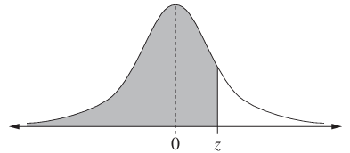
 | 0.00 | 0.01 | 0.02 | 0.03 | 0.04 | 0.05 | 0.06 | 0.07 | 0.08 | 0.09
0.0 | 0.5000 | 0.5040 | 0.5080 | 0.5120 | 0.5160 | 0.5199 | 0.5239 | 0.5279 | 0.5319 | 0.5359
0.1 | 0.5398 | 0.5438 | 0.5478 | 0.5517 | 0.5557 | 0.5596 | 0.5636 | 0.5675 | 0.5714 | 0.5753
0.2 | 0.5793 | 0.5832 | 0.5871 | 0.5910 | 0.5948 | 0.5987 | 0.6026 | 0.6064 | 0.6103 | 0.6141
0.3 | 0.6179 | 0.6217 | 0.6255 | 0.6293 | 0.6331 | 0.6368 | 0.6406 | 0.6443 | 0.6480 | 0.6517
0.4 | 0.6554 | 0.6591 | 0.6628 | 0.6664 | 0.6700 | 0.6736 | 0.6772 | 0.6808 | 0.6844 | 0.6879
0.5 | 0.6915 | 0.6950 | 0.6985 | 0.7019 | 0.7054 | 0.7088 | 0.7123 | 0.7157 | 0.7190 | 0.7224
0.6 | 0.7257 | 0.7291 | 0.7324 | 0.7357 | 0.7389 | 0.7422 | 0.7454 | 0.7486 | 0.7517 | 0.7549
0.7 | 0.7580 | 0.7611 | 0.7642 | 0.7673 | 0.7704 | 0.7734 | 0.7764 | 0.7794 | 0.7823 | 0.7852
0.8 | 0.7881 | 0.7910 | 0.7939 | 0.7967 | 0.7995 | 0.8023 | 0.8051 | 0.8078 | 0.8106 | 0.8133
0.9 | 0.8159 | 0.8186 | 0.8212 | 0.8238 | 0.8264 | 0.8289 | 0.8315 | 0.8340 | 0.8365 | 0.8389
1.0 | 0.8413 | 0.8438 | 0.8461 | 0.8485 | 0.8508 | 0.8531 | 0.8554 | 0.8577 | 0.8599 | 0.8621
1.1 | 0.8643 | 0.8665 | 0.8686 | 0.8708 | 0.8729 | 0.8749 | 0.8770 | 0.8790 | 0.8810 | 0.8830
1.2 | 0.8849 | 0.8869 | 0.8888 | 0.8907 | 0.8925 | 0.8944 | 0.8962 | 0.8980 | 0.8997 | 0.9015
1.3 | 0.9032 | 0.9049 | 0.9066 | 0.9082 | 0.9099 | 0.9115 | 0.9131 | 0.9147 | 0.9162 | 0.9177
1.4 | 0.9192 | 0.9207 | 0.9222 | 0.9236 | 0.9251 | 0.9265 | 0.9279 | 0.9292 | 0.9306 | 0.9319
1.5 | 0.9332 | 0.9345 | 0.9357 | 0.9370 | 0.9382 | 0.9394 | 0.9406 | 0.9418 | 0.9429 | 0.9441
1.6 | 0.9452 | 0.9463 | 0.9474 | 0.9484 | 0.9495 | 0.9505 | 0.9515 | 0.9525 | 0.9535 | 0.9545
1.7 | 0.9554 | 0.9564 | 0.9573 | 0.9582 | 0.9591 | 0.9599 | 0.9608 | 0.9616 | 0.9625 | 0.9633
1.8 | 0.9641 | 0.9649 | 0.9656 | 0.9664 | 0.9671 | 0.9678 | 0.9686 | 0.9693 | 0.9699 | 0.9706
1.9 | 0.9713 | 0.9719 | 0.9726 | 0.9732 | 0.9738 | 0.9744 | 0.9750 | 0.9756 | 0.9761 | 0.9767
2.0 | 0.9772 | 0.9778 | 0.9783 | 0.9788 | 0.9793 | 0.9798 | 0.9803 | 0.9808 | 0.9812 | 0.9817
2.1 | 0.9821 | 0.9826 | 0.9830 | 0.9834 | 0.9838 | 0.9842 | 0.9846 | 0.9850 | 0.9854 | 0.9857
2.2 | 0.9861 | 0.9864 | 0.9868 | 0.9871 | 0.9875 | 0.9878 | 0.9881 | 0.9884 | 0.9887 | 0.9890
2.3 | 0.9893 | 0.9896 | 0.9898 | 0.9901 | 0.9904 | 0.9906 | 0.9909 | 0.9911 | 0.9913 | 0.9916
2.4 | 0.9918 | 0.9920 | 0.9922 | 0.9925 | 0.9927 | 0.9929 | 0.9931 | 0.9932 | 0.9934 | 0.9936
2.5 | 0.9938 | 0.9940 | 0.9941 | 0.9943 | 0.9945 | 0.9946 | 0.9948 | 0.9949 | 0.9951 | 0.9952
2.6 | 0.9953 | 0.9955 | 0.9956 | 0.9957 | 0.9959 | 0.9960 | 0.9961 | 0.9962 | 0.9963 | 0.9964
2.7 | 0.9965 | 0.9966 | 0.9967 | 0.9968 | 0.9969 | 0.9970 | 0.9971 | 0.9972 | 0.9973 | 0.9974
2.8 | 0.9974 | 0.9975 | 0.9976 | 0.9977 | 0.9977 | 0.9978 | 0.9979 | 0.9979 | 0.9980 | 0.9981
2.9 | 0.9981 | 0.9982 | 0.9982 | 0.9983 | 0.9984 | 0.9984 | 0.9985 | 0.9985 | 0.9986 | 0.9986
3.0 | 0.9987 | 0.9987 | 0.9987 | 0.9988 | 0.9988 | 0.9989 | 0.9989 | 0.9989 | 0.9990 | 0.9990
3.1 | 0.9990 | 0.9991 | 0.9991 | 0.9991 | 0.9992 | 0.9992 | 0.9992 | 0.9992 | 0.9993 | 0.9993
3.2 | 0.9993 | 0.9993 | 0.9994 | 0.9994 | 0.9994 | 0.9994 | 0.9994 | 0.9995 | 0.9995 | 0.9995
- Identify probability less than or greater than positive z-score from a table
For $P\left(z≤c\right)$, read the value off the table.
Since $P\left(z≤c\right)+P\left(z≥c\right)=1$
$P\left(z≥c\right)=1-P\left(z≤c\right)$
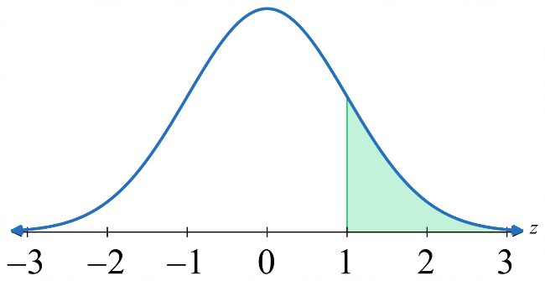
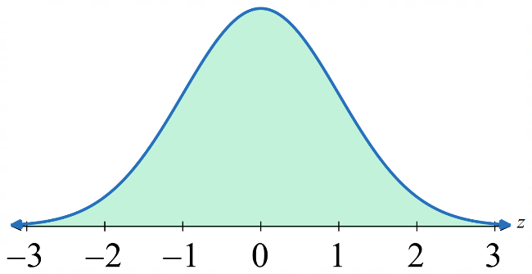
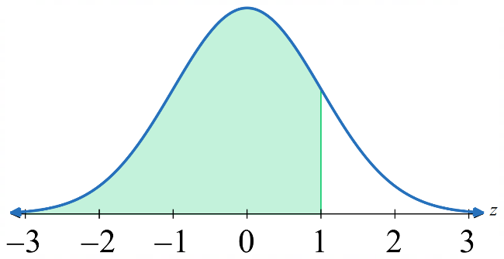

$=$ $-$

$P\left(z≥c\right) = 1 - P\left(z≤c\right)$.
- Find $P\left(z≤1.2\right)$  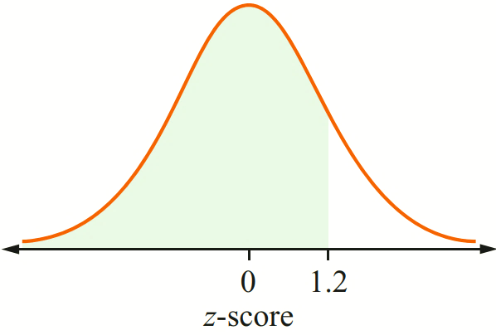  Reading off the table, $P\left(z≤1.2\right)=0.8849$ | - Find $P\left(z≤0.67\right)$  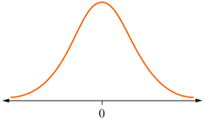
- Find $P\left(z≤1.83\right)$ | - Find $P\left(z≤2.34\right)$
- Find $P\left(z≥2.34\right)$  $$P\left(z>2.34\right)=1-P\left(z<2.34\right) \\ =1-0.9904 \\ =0.0096$$ | - Find $P\left(z≥1.23\right)$

- Identify probability between positive z-scores from a table
$$P\left(a≤z≤b\right)=P\left(z≤b\right)-P\left(z≤a\right)$$
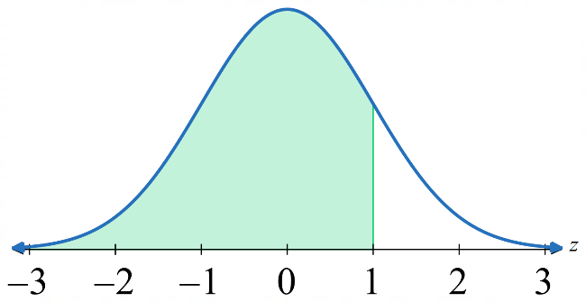
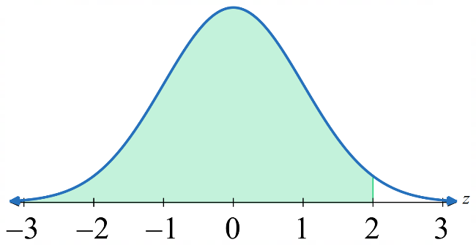
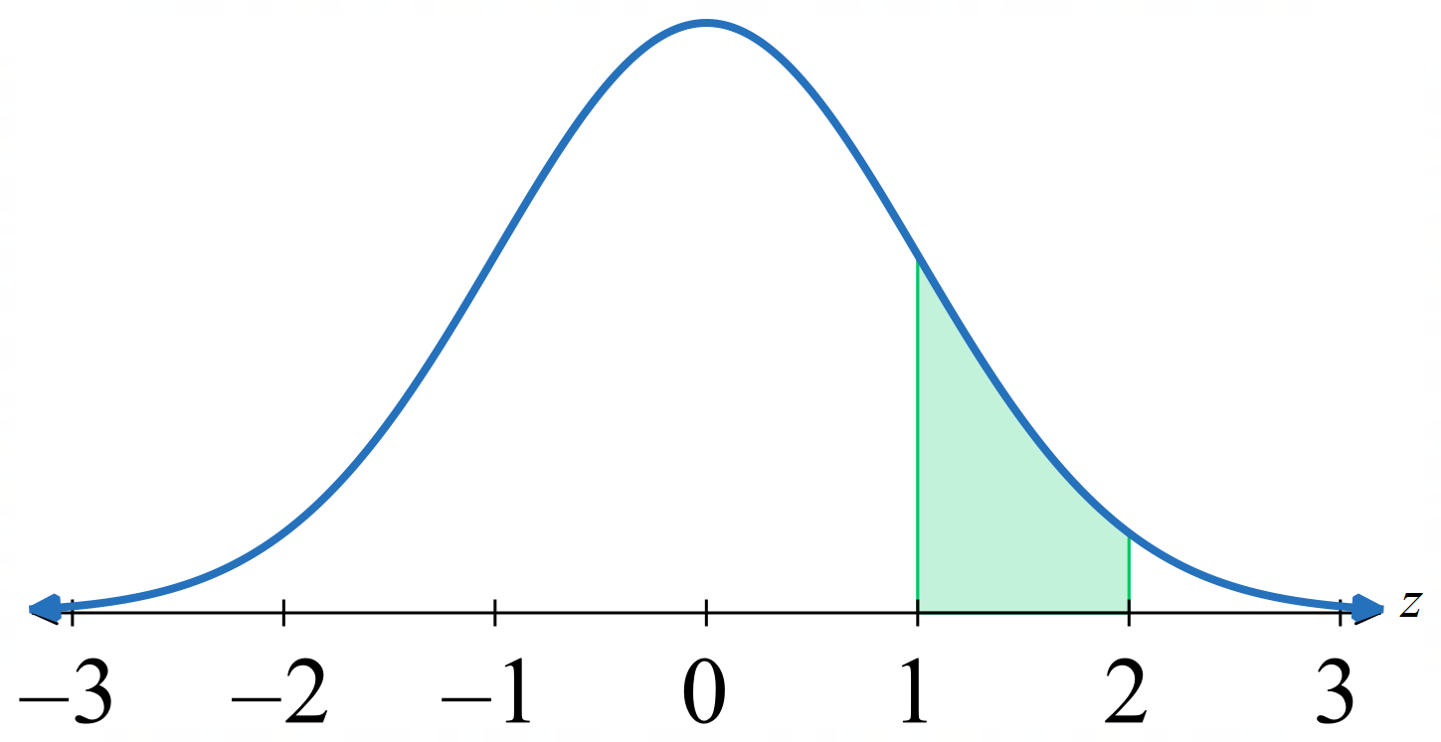

$=$ $-$

$P\left(a≤z≤b\right) = P\left(z≤b\right) - P\left(z≤a\right)$

- Find $P(1.2≤z≤2.34)$  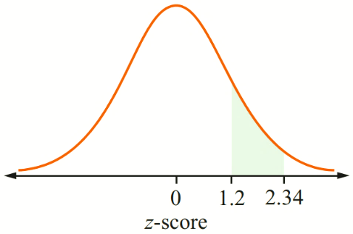  $$P\left(1.2<z<2.34\right)=P\left(z<2.34\right)-P\left(z<1.2\right) \\ =0.9904-0.8849 \\ =0.1055$$ | - Find $P\left(0.67≤z≤1.83\right)$
- Find $P(0.86≤z≤1.77)$ | - Find $P\left(1.05≤z≤1.92\right)$

- Z-score Identities (positive z-scores)
$P\left(z≤c\right):$ read off table

$$P\left(z≥c\right)=1-P\left(z≤c\right)$$

$$P\left(a≤z≤b\right)=P\left(z≤b\right)-P\left(z≤a\right)$$

- Finding Probabilities using a Calculator

Casio FX 8200AU:
1. Press HOME

2. Select

3. Select [Normal CD] (normal cumulative density; this finds $P\left(X≤c\right)$)
4. Enter data using the arrow keys and

5. After entering your data, press
Examples:
Mean: 100, SD: 10  Find $P\left(X≤110\right)$  Lower: $-∞$ (put -10000)  Upper: 110  $μ:$ 100  $σ:$ 10  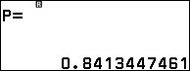 | Mean: 168, SD: 9  Find $P(X≥175$)  Lower: 175  Upper: $∞$ (put 10000)  $μ:$ 168  $σ:$ 9  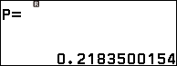 | When working with z-scores  Find $P\left(-1≤z≤1\right)$  Lower: $-1$  Upper: 1  $μ$: 0  $σ:$ 1  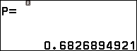
- If a table is given in an exam, use the provided table.

Foundation
The following table gives $P(Z≤z)$ for the standard normal distribution to 1 d.p.
$$z$$ | .0 | .1 | .2 | .3 | .4 | .5 | .6 | .7 | .8 | .9
0. | 0.5000 | 0.5398 | 0.5793 | 0.6179 | 0.6554 | 0.6915 | 0.7257 | 0.7580 | 0.7881 | 0.8159
1. | 0.8413 | 0.8643 | 0.8849 | 0.9032 | 0.9192 | 0.9332 | 0.9452 | 0.9554 | 0.9641 | 0.9713
2. | 0.9772 | 0.9821 | 0.9861 | 0.9893 | 0.9918 | 0.9938 | 0.9953 | 0.9965 | 0.9974 | 0.9981
3. | 0.9987 | 0.9990 | 0.9993 | 0.9995 | 0.9997 | 0.9998 | 0.9998 | 0.9999 | 0.9999 | 1.0000

- Use the table to find (correct to 4 d.p.):
- $P(Z≤0)$  0.5000 | - $P(Z≤1)$  0.8413 | - $P(Z≤2)$  0.9772 | - $P(Z≤1.5)$  0.9332
- $P(Z<0.4)$  0.6554 | - $P(Z≤2.3)$  0.9893 | - $P(Z<1.2)$  0.8849 | - $P(Z≤5)$  1.0000

- Explain why $P(Z>a)=1-P(Z≤a)$. Hence find:
- $P(Z>0)$  0.5 | - $P(Z>1)$  0.1587 | - $P(Z>2)$  0.0228 | - $P(Z≥2.4)$  0.0082
- $P(Z>1.3)$  0.0968 | - $P(Z>0.7)$  0.2420 | - $P(Z≥1.6)$  0.0548 | - $P(Z>8)$  0.0000

- Use the standard normal distribution table to find the probability of finding a value with z-score:
- Less than 1  $P\left(z<1\right)=$ ……………  0.8413 | - Less than 1.4  0.9192 | - More than 1.8  0.0359
- More than 2.25  0.0122 | - Between 0.4 and 1.78  0.3071 | - Between 1.32 and 1.78  0.0559

- A dataset is normally distributed with a mean of 75 and a standard deviation of 12. By first calculating the standardised score and using the standard normal distribution table, find the probability that a randomly chosen score is:
- less than 84  z-score: ………………  $P(z<$ ……$)=$ …………  0.7734 | - less than 79  0.6293 | - less than 100  0.9812
- more than 76  0.4681 | - more than 90  0.1057 | - more than 87  0.1587
- between 79 and 84  0.1441 | - between 80 and 100  0.3185 | - between 87 and 106  0.1538

- Adriana scored 70 in a test for which the marks were normally distributed with a mean of 64 and a standard deviation of 12. What is the probability that a randomly chosen student scored a lower mark than Adriana?

0.6915
- IQ is approximately normally distributed in Australia with mean 98 and standard deviation 15.
  - A genius is defined as IQ over 140. What percentage of the population is this?

$$z=\frac{140-98}{15}=2.8$$
$P(Z>2.8)=1-0.9974=0.0026=0.26\%$
  - In 25 million people, how many geniuses would you expect?

$0.0026×25 000 000=65 000$ geniuses
- A study found mean cholesterol level 219 mg/mL with standard deviation 41 mg/mL for adult males without heart disease.
Doctors classify a reading above 240 mg/mL as high.
What percentage of this population has high cholesterol?

$$z=\frac{240-219}{41}≈0.51$$
$$P(Z>0.51)=1-0.6950≈31\%$$

- The weights of 10 000 newborn babies in NSW are normally distributed. These weights have a mean of 3.1 kg and a standard deviation of 0.35 kg.
  - What is the probability that a randomly chosen baby has a weight between 3.24 kg and 3.66 kg?

0.2898
  - How many of the 10 000 newborn babies would have a weight between 3.24 kg and 3.66 kg?

2898

- Z-score Identities (negative z-scores)
The z-score table only gives positive values; for negative values we need to use symmetry.
$$P\left(z≤-c\right)=P\left(z≥c\right)$$
$=1-P\left(z≤c\right)$
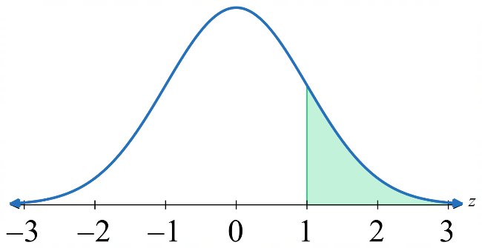
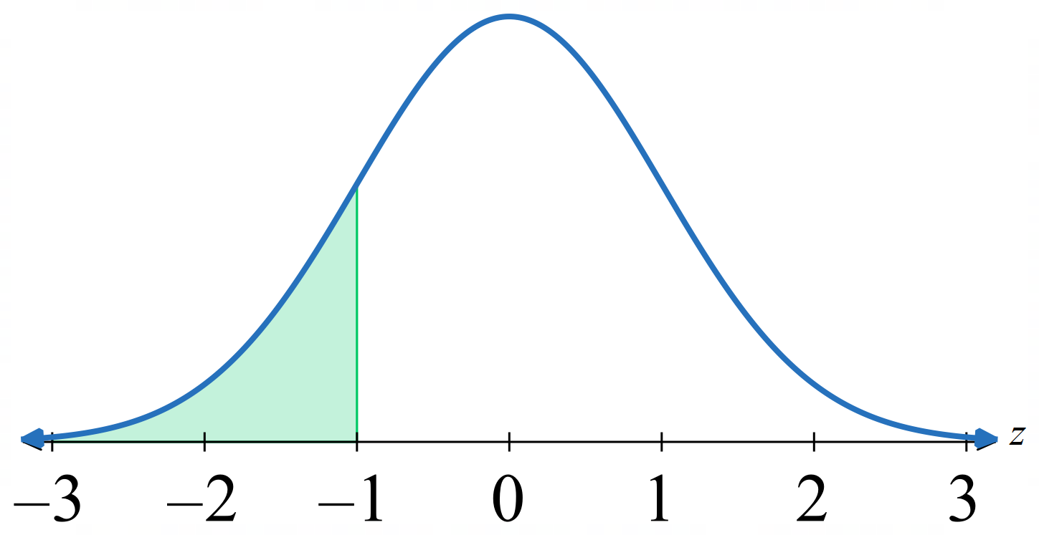

$P\left(z≤-c\right) = P\left(z≥c\right)$

$= 1 - P\left(z≤c\right)$

- Identify probability using negative z-scores from a table
- Find $P\left(z≤-0.86\right)$  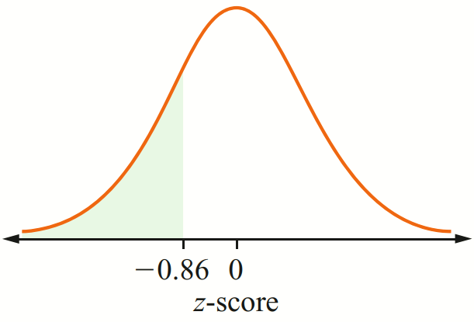  $$P\left(z≤-0.86\right)=P\left(z≥0.86\right) \\ =1-P\left(z≤0.86\right) \\ =1-0.8051 \\ ≈0.1949$$ | - Find $P\left(z≥-1.35\right)$  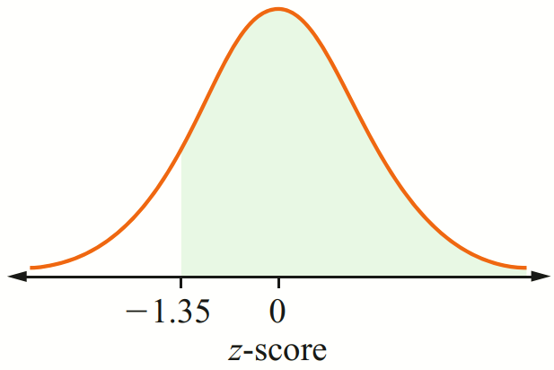  $P(z≥ -1.35)$  $=P\left(z≤1.35\right)$  $=0.9115$
- Find $P\left(z≤-0.78\right)$  0.2177 | - Find $P\left(z≥-0.33\right)$  0.6293

Development

  - Use symmetry of the normal distribution to explain why, for $a>0$,
$P(Z<-a)=1-P(Z≤a)$.

By the line symmetry of the bell curve about $z=0$, the area to the left of $-a$ equals the area to the right of $a$:
$P(Z<-a)=P(Z>a)=1-P(Z≤a)$.
  - Use this to find:
- $P(Z<-1.2)$  $$1-0.8849=0.1151$$ | - $P(Z≤-2.3)$  $$1-0.9893=0.0107$$ | - $P(Z<-0.2)$  $$1-0.5793=0.4207$$ | - $P(Z<-3.2)$  $$1-0.9993=0.0007$$
- $P(Z<-5)$  0.0000 | - $P(Z≤-0.7)$  $$1-0.7580=0.2420$$ | - $P(Z<-1.6)$  $$1-0.9452=0.0548$$ | - $P(Z≤-1.4)$  $$1-0.9192=0.0808$$

- Match these eight probabilities into four pairs with equal values:
a $P(Z≤2)$ b $P(Z≤-1)$ c $P(Z≤1.2)$ d $P(Z=4)$
e $P(Z<2)$ f $P(Z=2.3)$ g $P(Z≥1)$ h $P(Z>-1.2)$

a & e (both equal $P(Z≤2)=0.9772$)
b & g ($P(Z≤-1)=1-0.8413=0.1587=P(Z≥1)$)
c & h ($P(Z≤1.2)=0.8849=P(Z>-1.2)$)
d & f (both equal 0, since $P(Z=c)=0$ for any constant $c$)

- Match these eight probabilities into four pairs with equal values:
a $P(Z≤5)$ b $P(Z>-1.7)$ c $P(Z<5)$ d $P(Z≥2)$
e $P(Z=3)$ f $P(Z≤-2)$ g $P(Z≤1.7)$ h $P(Z=1.2)$

a & c (both $P(Z≤5)≈1.0000$)
b & g ($P\left(Z>-1.7\right)=P\left(Z≤1.7\right)=0.9554$)
d & f ($P(Z≥2)=1-0.9772=0.0228=P(Z≤-2)$)
e & h (both equal 0)

  - Use symmetry to explain why $P(Z≤0)=0.5$.

By symmetry, the bell curve is symmetric about $z=0$, so the area to the left and right of 0 are equal, each $=0.5$.
  - Hence use $P(0<Z≤a)=P(Z≤a)-0.5$ to find:
- $P(0<Z≤1.3)$  $$0.9032-0.5=0.4032$$ | - $P(0<Z≤2.4)$  $$0.9918-0.5=0.4918$$ | - $P(0<Z≤0.7)$  $$0.7580-0.5=0.2580$$
- $P(-2.4≤Z<0)$  0.4918 | - $P(-1.1≤Z<0)$  $$0.8643-0.5=0.3643$$ | - $P(-0.7≤Z<0)$  0.2580
- $P(0<Z≤1.6)$  $0.9452-0.5=0.4452$ | - $P(-1.3≤Z≤0)$  0.4032 | - $P(0<Z≤5)$  $$1.0000-0.5=0.5000$$

  - Show that $P(-a≤Z≤a)=2P(Z≤a)-1$

$$LHS = P(-a≤Z≤a)=P(Z≤a)-P\left(Z<-a\right)$$
$$=P(Z≤a)-\left[1-P\left(Z≤a\right)\right]$$
$$=P(Z≤a)-1+P(Z≤a)$$
$$2P(Z≤a)-1$$
  - Hence find:
- $P(-1.3≤Z≤1.3)$  $$2(0.9032)-1=0.8064$$ | - $P(-2.4<Z≤2.4)$  $$2(0.9918)-1=0.9836$$ | - $P(-0.8<Z<0.8)$  $$2(0.7881)-1=0.5762$$
- $P(-2.9<Z≤2.9)$  $$2(0.9981)-1=0.9962$$ | - $P(-0.4≤Z<0.4)$  $$2(0.6554)-1=0.3108$$ | - $P(-1.5<Z≤1.5)$  $$2(0.9332)-1=0.8664$$

- For a dataset that is normally distributed, find the probability that a randomly chosen score has a z-score:
- less than –1.42  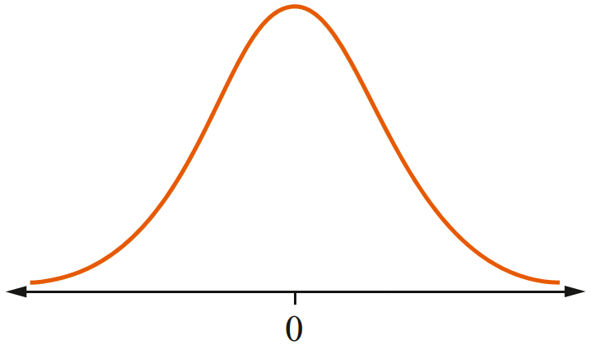  $$P(Z < -1.42)= 1 - P(Z < 1.42)$$  $$= 1 - 0.9222 = 0.0778$$ | - less than –2.21  $$P(Z < -2.21) = 1 - P(Z < 2.21)$$  $$= 1 - 0.9864 = 0.0136$$
- more than –1.19  $$P(Z > -1.19)$$  $$= P(Z < 1.19) = 0.8830$$ | - more than –2.07  $$P(Z > -2.07)$$  $$= P(Z < 2.07) = 0.9808$$

- Use $P(a≤Z≤b)=P(Z≤b)-P(Z≤a)$ to find:
- between –0.95 and –0.52  $$P(-0.95 < Z < -0.52)$$  $$= P(Z < -0.52) - P(Z < -0.95)$$  $$= [1 - P(Z < 0.52)] - [1 - P(Z < 0.95)]$$  $$= P(Z < 0.95) - P(Z < 0.52)$$  $$= 0.8289 - 0.6985 = 0.1304$$ | - between –1.96 and –1.24  $$P(-1.96 < Z < -1.24)$$  $$= P(Z < -1.24) - P(Z < -1.96)$$  $$= [1 - P(Z < 1.24)] - [1 - P(Z < 1.96)]$$  $$= P(Z < 1.96) - P(Z < 1.24)$$  $$= 0.9750 - 0.8925 = 0.0825$$
- $P(1.2≤Z<1.5)$  $$0.9332-0.8849=0.0483$$ | - $P(0.2≤Z<2.3)$  $$0.9893-0.5793=0.4100$$ | - $P(0.6≤Z<1.7)$  $$0.9554-0.7257=0.2297$$
- $P(-2≤Z<-1.2)$  $$P\left(Z≤-1.2\right)-P\left(Z≤-2\right)$$  $$=0.1151-0.0228$$  $$=0.0923$$ | - $P(-4≤Z<-0.2)$  $$P\left(Z≤-0.2\right)-P\left(Z≤-4\right)$$  $$=0.4207-0$$  $$=0.4207$$ | - $P(-2.7≤Z<-1)$  $$P\left(Z<-1\right)-P\left(Z<-2.7\right)$$  $$=0.1587-0.0035$$  $$=0.1552$$

- A machine produces cylindrical pipes. The mean of the diameters of the pipes is 7.00 cm and the standard deviation is 0.03 cm. Assuming a normal distribution, what is the probability that a randomly chosen pipe has a diameter less than 6.95 cm?

P(x < 6.95) = P(z < −1.67) = 0.0475

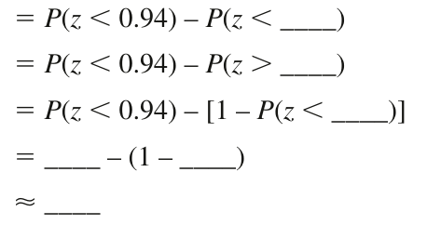
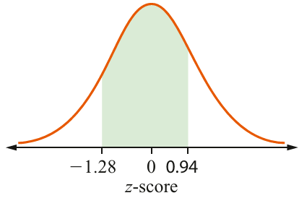
- Complete the following to calculate $P\left(-1.28<z<0.94\right)$.

P(−1.28 < z < 0.94)
= P(z < 0.94) − P(z < −1.28)
= P(z < 0.94) − P(z > 1.28)
= P(z < 0.94) − [1 − P(z < 1.28)]
= 0.8264 − (1 − 0.8997) ≈ 0.7261
- For a dataset that is normally distributed, nd the probability that a randomly chosen score has a z-score:
  - between –0.67 and 1.83

0.7150
  - between –1.41 and 2.15

0.9050
  - between –0.82 and 1.36

0.7070
- Packets of sugar are filled and labelled as having a weight of 1 kg. The weights of these packets are normally distributed with a mean of 1.01 kg and a standard deviation of 0.01 kg. A packet of sugar is rejected if its weight is lower than 985 g.
  - What is the probability that a randomly chosen packet of sugar is rejected?

P(x < 0.985) = P(z < −2.5) = 0.0062
  - From a batch of 1000 packets of sugar, how many packets would you expect to be rejected?

0.006 2 × 1000 ≈ 6; expect 6 packets to be rejected
- The lengths jumped by Year 8 long-jump competitors follow a normal distribution with a mean of 432 cm and a standard deviation of 14 cm.
  - Find the probability that a competitor jumps:
    - more than 445 cm

P(x > 445) = P(z > 0.93) = 0.1762
    - at least 410 cm

P(x > 410) = P(z > −1.57) = 0.9418
    - between 420 cm and 458 cm.

P(420 < x < 458) = P(−0.86 < z < 1.86) = 0.7737
  - A competitor jumps 486 cm. Is this unusual?

Yes, this is unusual as this length is nearly four standard deviations above the mean, which is a very small probability.

Mastery
- The heights of 1000 Year 12 males are found to be approximately normally distributed with a mean of 168 cm and standard deviation of 9 cm. Bradley is a Year 12 male whose height puts him just inside the top 10%. Find Bradley’s height, answer to 1 d.p.
  - Find the probability that a randomly chosen Year 12 male is taller than 175 cm.

P(x > 175) = P(z > 0.78) = 0.2177
  - Find the probability that a randomly chosen Year 12 male has a height less than 165 cm.

P(x < 165) = P(z < −0.33) = 0.3707
  - Find the probability that a randomly chosen Year 12 male has a height between 170 cm and 175 cm.

P(170 < x < 175) = P(0.22 < z < 0.78) = 0.1952
  - How many Year 12 males in the sample have a height between 170 cm and 175 cm?

0.1952 × 1000 ≈ 195; 195 Year 12 males

- Human gestation is approximately normally distributed with mean 266 days and standard deviation 16 days.
  - About $0.75×365≈274$ days is nine months. What percentage of females give birth before 274 days?

$$z=\frac{274-266}{16}=0.5$$
$$P(Z<0.5)=0.6915≈69\%$$
  - If 266 days is “on time”, what percentage give birth more than:
    - 1 week early

$$z=\frac{259-266}{16}=-0.4375≈-0.44$$
$P(Z<-0.44)=1-0.6700≈33\%$
    - 1 week late?

1 week late: birth after day 273
$$z=\frac{273-266}{16}≈0.44$$
$$P(Z>0.44)≈33\%$$

- A Jack Russell terrier has mean height 28 cm and standard deviation 0.833 cm.
  - What range of heights (to 1 d.p.) would you expect?

$μ±3σ=28±2.5$
25.5 cm to 30.5 cm
  - Find the $z$-score of 27.2 cm.

$$z=\frac{27.2-28}{0.833}≈-0.96$$
  - What percentage of dogs are between 27.2 and 30 cm tall?

$$z\left(27.2\right)≈-0.96$$
$$z\left(30\right)=\frac{30-28}{0.833}≈2.4$$
$$P\left(-0.96≤Z≤2.4\right)=0.9918-\left(1-0.8315\right)$$
$$=82.33\%$$
  - Would a dog 24 cm tall be typical? Why?

$$z=\frac{24-28}{0.833}≈-4.8$$
Far outside normal range; not typical.
- Pulse rates for adult males aged 20–39 are approximately normally distributed with mean 71 and standard deviation 9.
  - Bradycardia is a pulse rate below 60 beats/minute.
What percentage of this population has bradycardia?

$$z=\frac{60-71}{9}=-1.22≈-1.2$$
$$P(Z<-1.2)=1-0.8849≈12\%$$
  - Tachycardia is a pulse rate above 100 beats/minute. What percentage?

$$z=\frac{100-71}{9}≈3.2$$
$$P(Z>3.2)=1-0.9993≈0.07\%$$
  - Repeat a and b for females aged 20–39 with mean 76 and standard deviation 9.5.

Bradycardia:
$$z=\frac{60-76}{9.5}≈-1.7$$
$P(Z<-1.7)=1-0.9554≈4.5\%$
Tachycardia:
$$z=\frac{100-76}{9.5}≈2.5$$
$$P(Z>2.5)=1-0.9938≈0.6\%$$

Finding $μ$ or $σ$ given a Probability

- Identify z from the table, given probability
- $P(Z < z) = 0.9772$.  Find the value of $z$. | - $P(Z < z) = 0.9332$.  Find the value of $z$.
- $P(Z < z) =0.8413$.  Find the value of $z$. | - $P(Z < z) = 0.0228.$  Find the value of $z$.

- Finding $μ$ or $σ$
Sometimes you are given the probability and asked to find the mean or standard deviation.
1. Find $z$ using the table.
2. Set up an equation using $z=$ $\frac{x-μ}{σ}$.
3. Solve for the unknown.

- Example Find $μ$ or $σ$ given the probability
X is normally distributed with standard deviation 6. Given that $P(X < 47) = 0.9772$, find the mean $μ$.  Using the table, $P\left(Z≤2\right)=0.9772$.  So $z=2$:  $$2=\frac{47-μ}{6} \\ 12=47-μ \\ μ=35$$ | A company manufactures chocolate bars with standard deviation 2 g. What would the mean weight need to be for there to be less than 0.1% chance of a bar being under 100 g?  We want $P\left(Z≤z\right)=0.001$  This would be a negative z-score, so  $$P\left(Z≤-z\right)=P\left(Z≥z\right) \\ =1-P\left(Z≤z\right) \\ =1-0.001 \\ =0.999$$  Using the table, $P\left(Z≤3.1\right)=0.999$  So $z=-3.1:$  $$-3.1=\frac{100-μ}{2} \\ -6.2=100-μ \\ μ=106.2 g$$
- Guided Practice
- $X$ is normally distributed with mean 35. Given $P(X < 47) = 0.9772$, find $σ$.

6
- $X$ is normally distributed with SD 6. Given $P(X < 47) = 0.0228$, find $μ$.

59
- $X$ is normally distributed with SD 10. Given $P(X > 85) = 0.0668$, find $μ$.

70
- A machine fills bottles of water with a standard deviation of 5 mL. What mean volume must be set so that fewer than 0.13% of bottles contain less than 330 mL?

345 mL

- Finding Probabilities using a Calculator
Casio FX 8200AU:
1. Press HOME
2. Select
3. Select [Inverse Normal] (this finds $x$ for $P\left(X≤x\right)=c$)
4. Enter data using the arrow keys and
5. After entering your data, press
Examples:
Mean: 100, SD: 10  Find the value of $x$ such that  $$P\left(X≤x\right)=0.9$$  Area: 0.9  $μ$: 100  $σ:$ 10  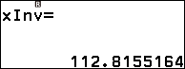  This means a measurement of 112.82 is better than 90% of measurements (top 10%) | When working with z-scores  Find the value of $z$ such that  $$P\left(Z≤z\right)=0.8$$  Area: 0.8  $μ$: 0  $σ:$ 1  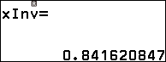  This means a z-score of 0.84 is better than 80% of measurements (top 20%)
- If a table is given in an exam, use the provided table.

Foundation
- Find the z-score such that a value just beats 80% of values (the top 20%) of a normal distribution.

We want a z-score with $P(Z ≤ z) = 0.80$
Using the table, or inverse normal on a calculator, this corresponds to a z-score of $≈ 0.84$
- Find the z-score for the value that is better than 65% of all measurements.

We want a z-score with $P(Z ≤ z) = 0.65$
Using the table, or inverse normal on a calculator, this corresponds to a z-score of $≈ 0.39$
- Exam scores are normally distributed with mean 65 and standard deviation 12.
A student scores better than 80% of the cohort. Find their score to 1 d.p.

We want a z-score with $P(Z ≤ z) = 0.80$
Using the table, or inverse normal on a calculator, this corresponds to a z-score of $≈ 0.84$
$$x = 65 + 0.84(12) = 75.1$$
- The lifespan of a brand of light bulb is normally distributed with mean 1200 hours and standard deviation 80 hours. A bulb lasts longer than 95% of bulbs of this brand. Find its lifespan to 1 d.p.

We want a z-score with $P(Z ≤ z) = 0.95$
Using the table, or inverse normal on a calculator, this corresponds to a z-score of $≈ 1.64$
$x = 1200 + 1.64(80) =$ 1331.2 hours
- Daily rainfall in a city is normally distributed with mean 4.2 mm and standard deviation 1.5 mm. On a particular day, rainfall exceeds 75% of all recorded days. Find that day's rainfall to 1 d.p.

We want a z-score with $P(Z ≤ z) = 0.75$
Using the table, or inverse normal on a calculator, this corresponds to a z-score of $≈ 0.67$
$x = 4.2 + 0.67(1.5) = 5.2$ mm

Development
- Heights of Year 12 males are approximately normally distributed with mean 168 cm and standard deviation 9 cm. Bradley is a Year 12 male whose height puts him just inside the top 10%. Find Bradley’s height, answer to 1 d.p.

We want a z-score with $P\left(Z≤z\right)=0.9$
Using the table, or inverse normal on a calculator, this corresponds to a z-score of $≈$1.28
$x=168+1.28\left(9\right)=$ 179.5 cm

- IQ scores are normally distributed with mean 100. 10% of the population score above 125.
Find the standard deviation to 1 d.p.

z = invNorm(0.9) ≈ 1.2816;
125 = 100 + 1.2816σ
σ = 25 ÷ 1.2816 = 19.5
- Apple weights from an orchard are normally distributed with standard deviation 15 g.
20% of apples weigh more than 185 g. Find the mean weight to 1 d.p.

z = invNorm(0.80) ≈ 0.8416;
185 = μ + 0.8416(15)
μ = 185 − 12.6 = 172.4 g
- Phone battery lives are normally distributed with mean 18 hours.
8% of phones last fewer than 14 hours. Find the standard deviation to 1 d.p.

z = invNorm(0.08) ≈ −1.4051;
14 = 18 − 1.4051σ
σ = 4 ÷ 1.4051 = 2.8 hours

- Australian adult male heights are normally distributed with mean 176 cm and standard deviation 7.5 cm. A doorway is designed so 90% can enter without ducking.
  - Find the $z$-score such that $P(Z<z)=90\%$ (to 1 d.p.).

Need $P(Z<z)=0.90$. From table: $P(Z≤1.2)=0.8849$, $P(Z≤1.3)=0.9032$.
$z≈1.3$.
  - Find the minimum doorway height, to nearest cm.

$x≈176+1.3(7.5)≈186$ cm
  - In the Dinaric Alps, male heights have mean 185 cm and standard deviation 7.5 cm.
A doorway is needed so 95% can enter without ducking.
    - Explain why a reasonable estimate for $P(Z<z)=0.95$ is $z=1.65$.

$P(Z≤1.6)=0.9452$ and $P(Z≤1.7)=0.9554$.
Since $0.95$ lies between these, a reasonable estimate is the midpoint $z≈1.65$.
    - Find the minimum design height.

$x=185+1.65(7.5)=185+12.375≈197$ cm
- A machine fills cereal boxes with mean 500 g and standard deviation 2 g. To ensure boxes are above the advertised weight at least 95% of the time, what weight should be printed on the box?

Need $P(X≥x_{0})=0.95$, so $P(X<x_{0})=0.05$, giving $z_{0}≈-1.65$. $x_{0}=500+(-1.65)(2)=496.7$ g.
The box should be marked 496 g (2σ below mean, so 97.5% of boxes weigh above this).

Equation of the PDF

- Normal Distribution Notation
Concise notation for ‘$X$ is normally distributed with mean $μ$ and standard deviation $σ$’:

$$X\sim N\left(μ,σ^{2}\right)$$

- Identify mean and standard deviation
- $X\sim N\left(70, 5^{2}\right)$ | - $X\sim N\left(70, 25\right)$ | - $X\sim N\left(-{10,28}^{2}\right)$
- $X\sim N\left(-10, 30\right)$ | - $X\sim N\left(268, 9^{2}\right)$ | - $X\sim N\left(0, 1\right)$

- Standard Normal Curve
The standard normal curve is $X\sim N\left(0,1\right)$.
It has a mean of 0 and standard deviation 1.
It describes the spread of z-scores.

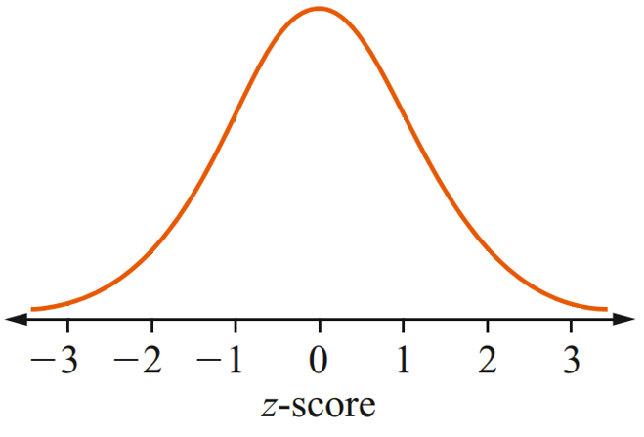
Any normal distribution can be transformed to the standard normal curve using the mapping:
$$x↦\frac{x-μ}{σ}$$

raw scores $x$

- PDF for Standard Normal Curve
For any normal curve with $μ$and $σ$:
$$f\left(x\right)=\frac{1}{σ\sqrt{2π}}· e^{-\frac{{\left(x - μ\right)}^{2}}{2σ^{2}}}$$
For the standard normal curve $μ=0, σ=1$:
$$ϕ\left(z\right)=\frac{1}{\sqrt{2π}}e^{-\frac{1}{2} z^{2}}$$
Notice that every normal curve is a transformation of the standard curve $f\left(x\right)=ϕ\left(\frac{x-μ}{σ}\right)$
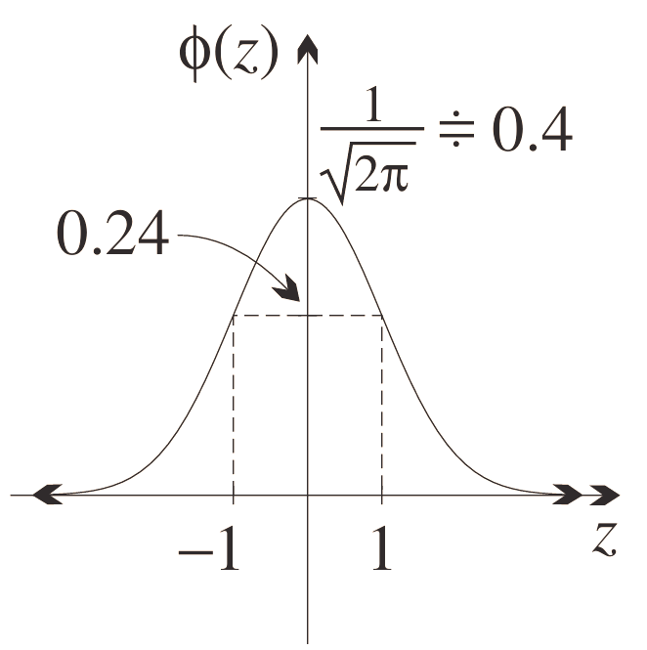
The standard curve $ϕ\left(z\right)$ has these properties:
- Total area under the curve is 1.
- Even symmetry.
- Mean, median, mode (global max) at $z=0$.
- $y$-intercept at $\frac{1}{\sqrt{2π}}$ $≈0.4$.
- $y→0$ as $z→±∞$
- Points of inflection are 1 SD from the mean.

Foundation
- Let $X$ denote a normal random variable with mean 0 and standard deviation 1. The random variable $X$ has the probability density function
$$f(x)=\frac{1}{\sqrt{2π}}e^{\frac{-x^{2}}{2}} \text{where }x∈(-∞,∞)$$
The diagram shows the graph of $y=f(x)$.
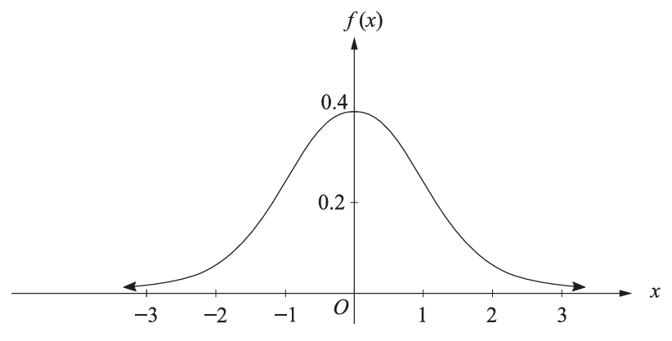

  - Complete the table of values for the given function, correct to four decimal places.
$$X=x$$ | $$-2$$ | $$-1$$ | $$0$$ | $$1$$ | $$2$$
$$f(x)$$ |  | 0.2420 |  | 0.2420
0.0540 0.2420 0.3989 0.2420 0.0540
  - Use the trapezoidal rule and 5 function values from part a to estimate $\int_{-2}^{2}{f}(x) dx$.

Trapezoidal rule with $h=1$
$$\int_{-2}^{2}{f}(x) dx≈\frac{1}{2}[0.0540+2(0.2420+0.3989+0.2420)+0.0540]≈0.9369$$
  - The weights of Rhodesian ridgebacks are normally distributed with a mean of 48 kilograms and a standard deviation of 6 kilograms. Using the result from part b, calculate the probability of a randomly selected Rhodesian ridgeback weighing less than 36 kilograms.

$$z score \left(36\right)=\frac{36-48}{6}=-2$$
$$By symmetry, P\left(X<36\right)=P\left(z<-2\right)=\frac{1-0.9369}{2}=3.155\%$$

- The diastolic measurement for blood pressure in 35-year-old people is normally distributed with a mean of 75 and a standard deviation of 12.
  - A person is considered to have low blood pressure if their diastolic measurement is 63 or less. What percentage of 35-year-olds have low blood pressure?

$$z score \left(63\right)=\frac{63-75}{12}=-1$$
$$P(\text{bp}≤63)=P(z≤-1)=\frac{100-68}{2}=16\%$$
  - Calculate the $z$-score for a diastolic measurement of 57.

$$z\text{-score}(57)=\frac{57-75}{12}=-1.5$$
  - The probability that a 35-year-old person has a diastolic measurement between 57 and 63 can be found by evaluating $\int_{a}^{b}{f}(x) dx$, where $a$ and $b$ are constants and $f(x)=\frac{1}{\sqrt{2π}}e^{\frac{-x^{2}}{2}}$ is the standard normal PDF. By first finding $a$ and $b$, calculate an approximate value for this probability using the trapezoidal rule with 3 function values.

Convert 57 and 63 to $z$-scores: $a=-1.5$, $b=-1$
$$\text{bp}$$ | 57 | 60 | 63
$$x$$ | $$-1.5$$ | $$-1.25$$ | $$-1$$
$$y$$ | 0.1295 | 0.1826 | 0.2420
Trapezoidal rule with $h=0.25$:
$$\text{Area}≈\frac{0.25}{2}(0.1295+2×0.1826+0.2420)≈0.0920≈9.2\%$$
  - Hence, find the approximate probability that a 35-year-old person chosen at random has a diastolic measurement of 57 or less.

From part a: $P(\text{bp}≤63)=16\%$.
$$P(\text{bp}≤57)=16\%-9.2\%=6.8\%$$

Exam Practice
- 2010 HSC Standard 2 Band 3
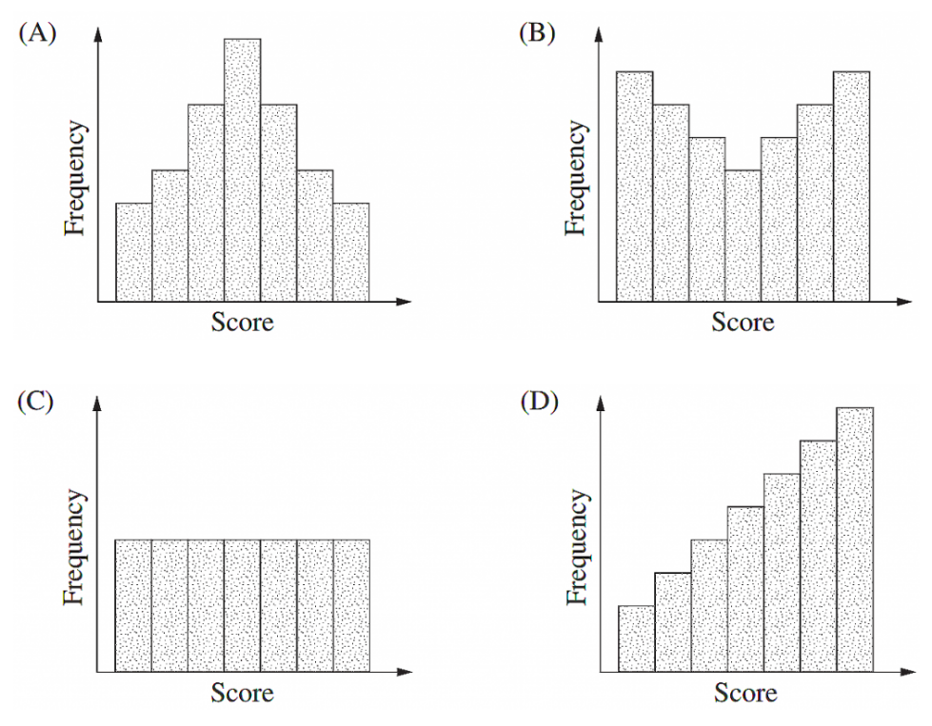
Which of the following frequency histograms shows data that could be normally distributed?

A normal distribution is bell-shaped and symmetric.
Answer: A.

- 2017 HSC Standard 2 Band 3
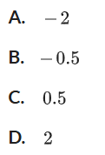
The heights of Year 12 girls are normally distributed with a mean of 165 cm and a standard deviation of 5.5 cm. What is the z-score for a height of 154 cm?

$$z=\frac{154-165}{5.5}=-2$$
Answer: A.
- HSC Sample Question Band 4
The length of a type of ant is approximately normally distributed with a mean of 4.8 mm and a standard deviation of 1.2 mm.
A standardised ant length of $z=-0.5$ corresponds to an actual ant length of:
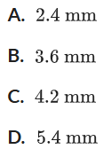

$x=μ+zσ=4.8+(-0.5)(1.2)=4.2$ mm.
Answer: C.

- 2018 HSC Standard 2 Band 4
Joanna sits a Physics test and a Biology test. Joanna’s mark in the Physics test is 70.
The mean mark for this test is 58 and the standard deviation is 8.
  - Calculate the z-score for Joanna’s mark in this test.

$$z=\frac{70-58}{8}=1.5$$
  - In the Biology test, the mean mark is 64 and the standard deviation is 10.
Joanna’s z-score is the same in both the Physics test and the Biology test.
What was her mark in Biology?

$$x=64+1.5×10=79$$
- 2020 HSC Standard 2 Band 4
John recently did a class test in each of three subjects.
The class scores on each test were normally distributed.
The table shows the subjects and John's scores as well as the mean and standard deviation of the class scores on each test.
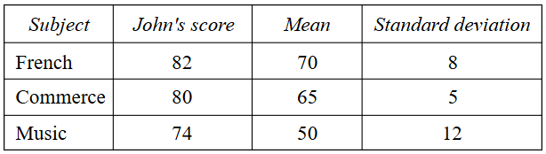

Relative to the rest of class, which row of the table below shows John's strongest subject and his weakest subject?
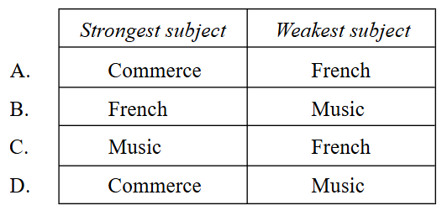

French: $z=\frac{82-70}{8}=1.5$
Commerce: $z=\frac{80-65}{5}=3$
Music: $z=\frac{74-50}{12}=2$
Strongest: Commerce ($z=3$), weakest: French ($z=1.5$). Answer: A.

- 2006 HSC Standard 2 Band 5
Which of these graphs best represents positively skewed data with the smaller standard deviation?
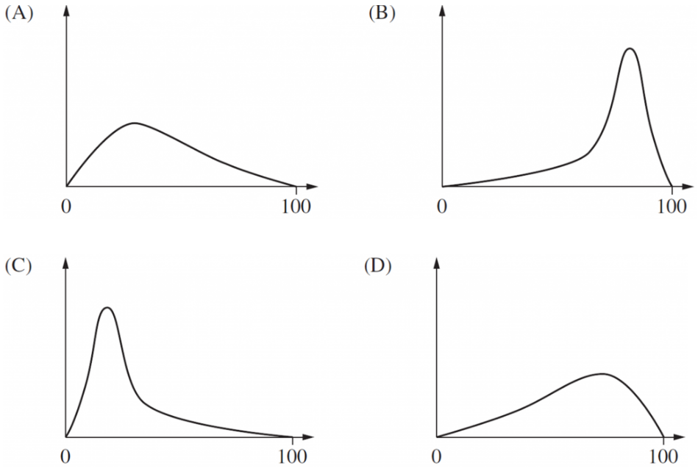

Positively skewed = tail to the right; smaller SD = narrower spread.
Answer: C.
Explain why the graph you have chosen is NOT a normal distribution.
It is not bell-shaped.

- HSC Sample Question Band 5
The pulse rates of a large group of 18-year-old students are approximately normally distributed with a mean of 75 beats/minute and a standard deviation of 11 beats/minute.
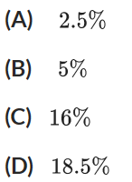
The percentage of 18-year-old students with pulse rates less than 53 beats/minute or greater than 86 beats/minute is closest to

$z_{53}=\frac{53-75}{11}=-2$, so $P(z<-2)=2.5\%$
$z_{86}=\frac{86-75}{11}=1$, so $P(z>1)=16\%$
$2.5+16=18.5\%$. Answer: D.

- 2011 HSC Standard 2 Band 5
Two brands of light bulbs are being compared.
For each brand, the life of the light bulbs is normally distributed.
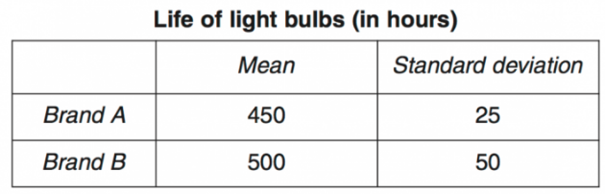

  - One of the Brand B light bulbs has a life of 400 hours.
What is the z-score of the life of this light bulb?

$$z=\frac{400-500}{50}=-2$$
  - A light bulb is considered defective if it lasts less than 400 hours.
The following claim is made:
‘Brand A light bulbs are more likely to be defective than Brand B light bulbs.’
Is this claim correct? Justify your answer, with reference to z-scores or standard deviations or the normal distribution.

Brand A: $z=\frac{400-450}{25}=-2$.
Both brands have $z=-2$ for 400 hours, so equal probability of being defective. The claim is incorrect.

- 2004 HSC Standard 2 Band 5
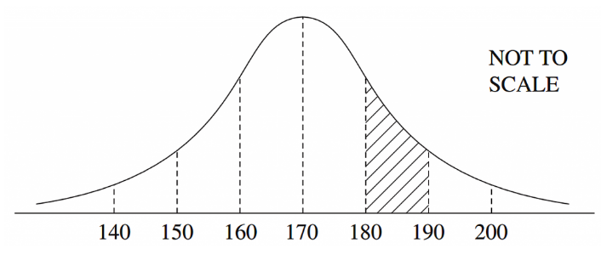
The normal distribution shown has a mean of 170 and a standard deviation of 10.

  - Roberto has a raw score in the shaded region. What could his z-score be?

Shaded region is 180 to 190, corresponding to $z=1$ to $z=2$.
Any value in that range, e.g., $z=1.5$.
  - What percentage of the data lies in the shaded region?

Using empirical rule, $13.5\%$
- 2014 HSC Standard 2 Band 5
The weights of 10 000 newborn babies in NSW are normally distributed. These weights have a mean of 3.1 kg and a standard deviation of 0.35 kg. How many of these newborn babies have a weight between 2.75 kg and 4.15 kg?

$z_{2.75}=\frac{2.75-3.1}{0.35}=-1$, $z_{4.15}=\frac{4.15-3.1}{0.35}=3$
$$P(-1<z<3)=83.85\%$$
$$0.8385×10 000=8385$$
- 2023 HSC Standard 2 Band 5
A random variable is normally distributed with a mean of 0 and a standard deviation of 1. The table gives the probability that this random variable lies below $z$ for some positive values of $z$.
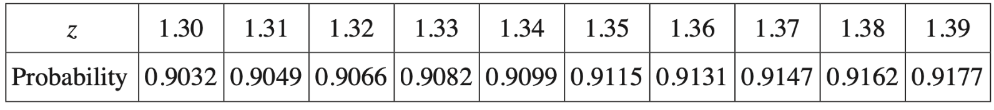

The weights of adult male koalas form a normal distribution with mean $μ$ = 10.40 kg, and standard deviation $σ$ = 1.15 kg.
In 400 adult male koalas, how many would be expected to weigh more than 11.93 kg?

$$z=\frac{11.93-10.40}{1.15}=1.33$$
z-score of 11.93 is $z=1.33$
using the table, $P\left(z>1.33\right)=1-0.9082=0.0918$
expected koalas $f=np=400×0.0918$
$=37$ koalas
- 2015 HSC Standard 2 Band 5
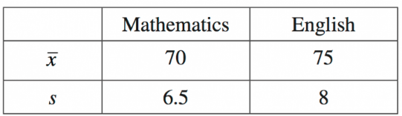
The results of two tests are normally distributed. The mean and standard deviation for each test are displayed in the table.

Kristoff scored 74 in Mathematics and 80 in English. He claims that he has performed better in English. Is Kristoff correct? Justify your answer using appropriate calculations.

Maths z-score: 0.6153…
English z-score: 0.625
He is correct.
- 2013 HSC Standard 2 Band 5
Ali’s class sits two Geography tests. The results of her class on the first Geography test are shown.

  - The mean was 68.5 for the first test. Calculate the standard deviation for the first test.
Give your answer correct to one decimal place.

Using a calculator: 5.2
  - On the second Geography test, the mean for the class was 74.4 and the standard deviation was 12.4. Ali scored 62 on the first test. Calculate the mark that she needed to obtain in the second test to ensure that her performance relative to the class was maintained.

Ali’s $z$-score in test 1: $z=\frac{62-68.5}{5.2}=-1.25$
Test 2 mark: $x=74.4+(-1.25)(12.4)=58.9$
- 2019 HSC Standard 2 Band 6
The scores on an examination are normally distributed with a mean of 70 and a standard deviation of 6. Michael received a score on the examination between the lower quartile and the upper quartile of the scores.
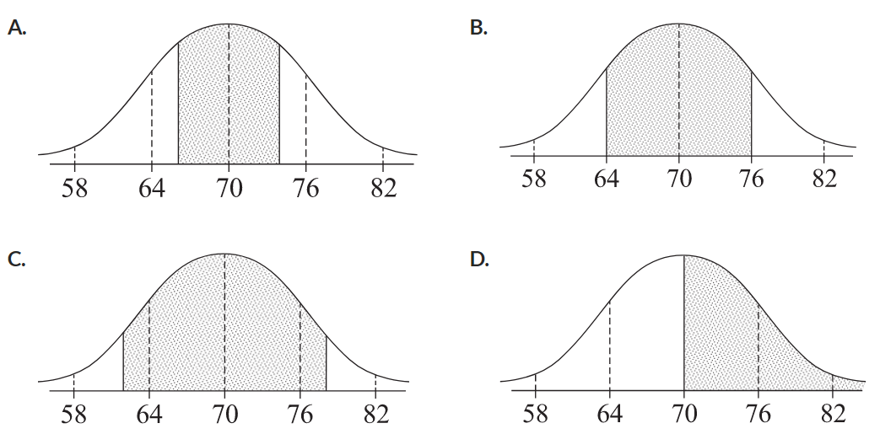
Which shaded region most accurately represents where Michael's score lies?

The IQR covers the middle 50%, which is narrower than the 68% within one standard deviation.
The shaded region must be narrower than $±1σ$ from the mean.
Answer: A.

- 2017 HSC Standard 2 Band 6
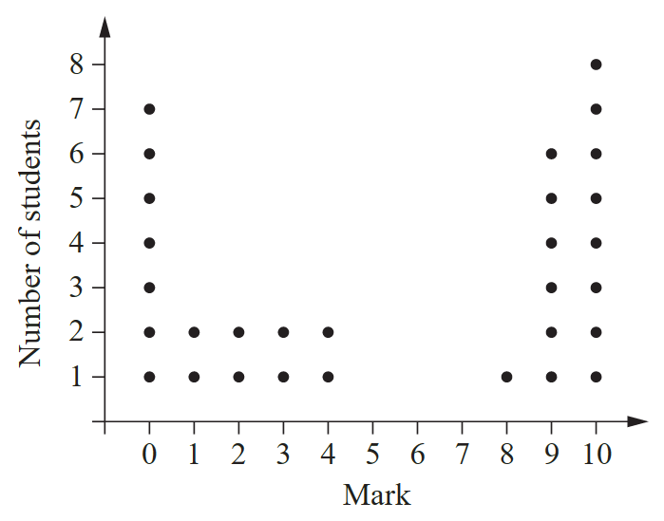
All the students in a class of 30 did a test. The marks, out of 10, are shown in the dot plot.

  - Find the median test mark
Median (average of 15th and 16th values) $=6$
  - The mean test mark is 5.4. The standard deviation of the test marks is 4.22.
Using the dot plot, calculate the percentage of the marks which lie within one standard deviation of the mean.

One SD range: $5.4-4.22=1.18$ to $5.4+4.22=9.62$, so marks 2 to 9. Count from dot plot: 13 scores.
$$\frac{13}{30}≈43\%$$
  - A student states that for any normally distributed data set, 68% of the scores should lie within one standard deviation of the mean (this is correct, as you will learn next lesson). With reference to the dot plot, explain why the student’s statement is NOT relevant in this context.

The data is not normally distributed (it is bimodal), so the 68% rule does not apply.

- 2022 HSC Standard 2 Band 6
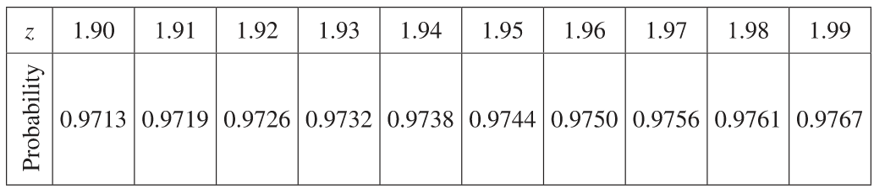
A random variable is normally distributed with mean 0 and standard deviation 1. The table gives the probability that this random variable lies below $z$ for some positive values of $z$.

The probability values given in the table are represented by the shaded area in the diagram.
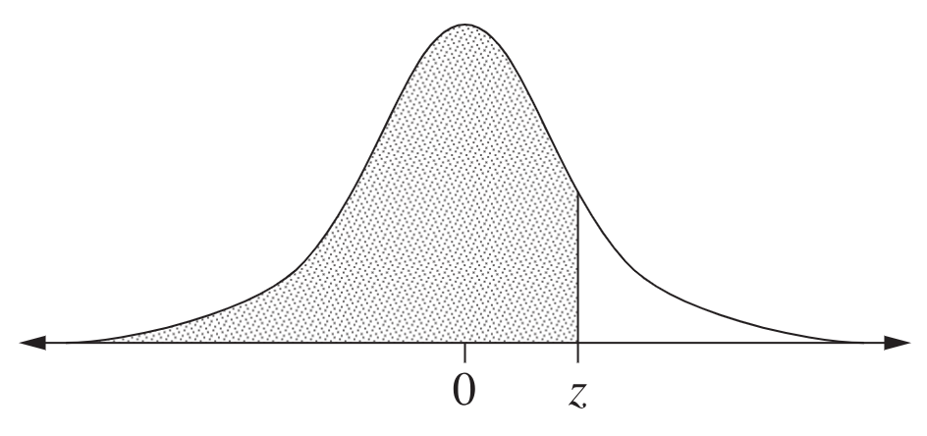

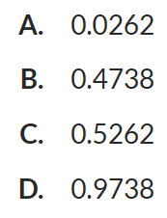
What is the probability that a normally distributed random variable with mean 0 and standard deviation 1 lies between 0 and 1.94?

$$P\left(0<z<1.94\right)=P\left(z<1.94\right)-0.5$$
$=0.9738-0.5=0.4738$.
Answer: B.

- 2021 HSC Standard 2 Band 6
A random variable is normally distributed with mean 0 and standard deviation 1. The table gives the probability that this random variable lies below $z$ for some positive values of $z$.
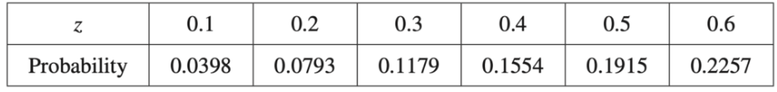

The probability values given in the table for different values of $z$ are represented by the shaded area in the following diagram.
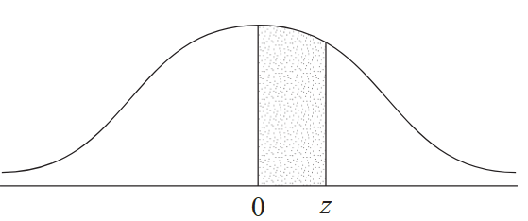

  - Using the table, show that the probability that a value from a random variable that is normally distributed with mean 0 and standard deviation 1 is greater than 0.3 is equal to 0.3821.

By symmetry, $P(z>0)=0.5$.
From table, $P(0<z<0.3)=0.1179$.
$$P(z>0.3)=0.5-0.1179=0.3821$$
  - Birth weights are normally distributed with a mean of 3300 grams and a standard deviation of 570 grams. By first calculating a z-score, find how many babies, out of 1000 born, are expected to have a birth weight greater than 3471 grams.

$$z=\frac{3471-3300}{570}=0.3$$
$$P(z>0.3)=0.3821$$
$$f=1000×0.3821=382$$

- 2024 HSC Standard 2 Band 6
A random variable is normally distributed with a mean of 0 and a standard deviation of 1. The table gives the probability that this random variable lies below $z$ for some positive values of $z$.
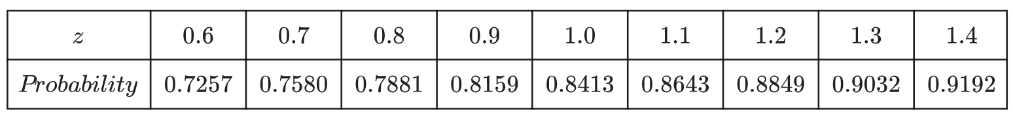

The probability values given in the table are represented by the shaded area in the diagram.

The scores in a university examination with a large number of candidates are normally distributed with mean 58 and standard deviation 15.
  - By calculating a z-score, find the percentage of scores that are between 58 and 70.

$$z=\frac{70-58}{15}=0.8$$
$$P\left(58<x<70\right)=P\left(0<z<0.8\right)$$
$$=0.7881-0.5=0.2881=28.81\%$$
  - Explain why the percentage of scores between 46 and 70 is twice your answer to part (a)

$46=58-12$ and $70=58+12$; both are the same distance from the mean on opposite sides.
By symmetry of the normal distribution, $P(46<x<58)=P(58<x<70)$,
so the percentage between 46 and 70 is double.
  - By using the values in the table above, find an approximate minimum score that a candidate would need to be placed in the top 10% of the candidates

Top 10% requires $P(Z<z)≈0.90$. From the table, $P(z<1.3)=0.9032≈0.90$.
$$x=58+1.3×15=77.5$$

